ADRIFT-ACCESS in the Greater Farallones and Cordell Bank Sanctuary: Passive Acoustic Monitoring in the California Current using Drifting Recorders

[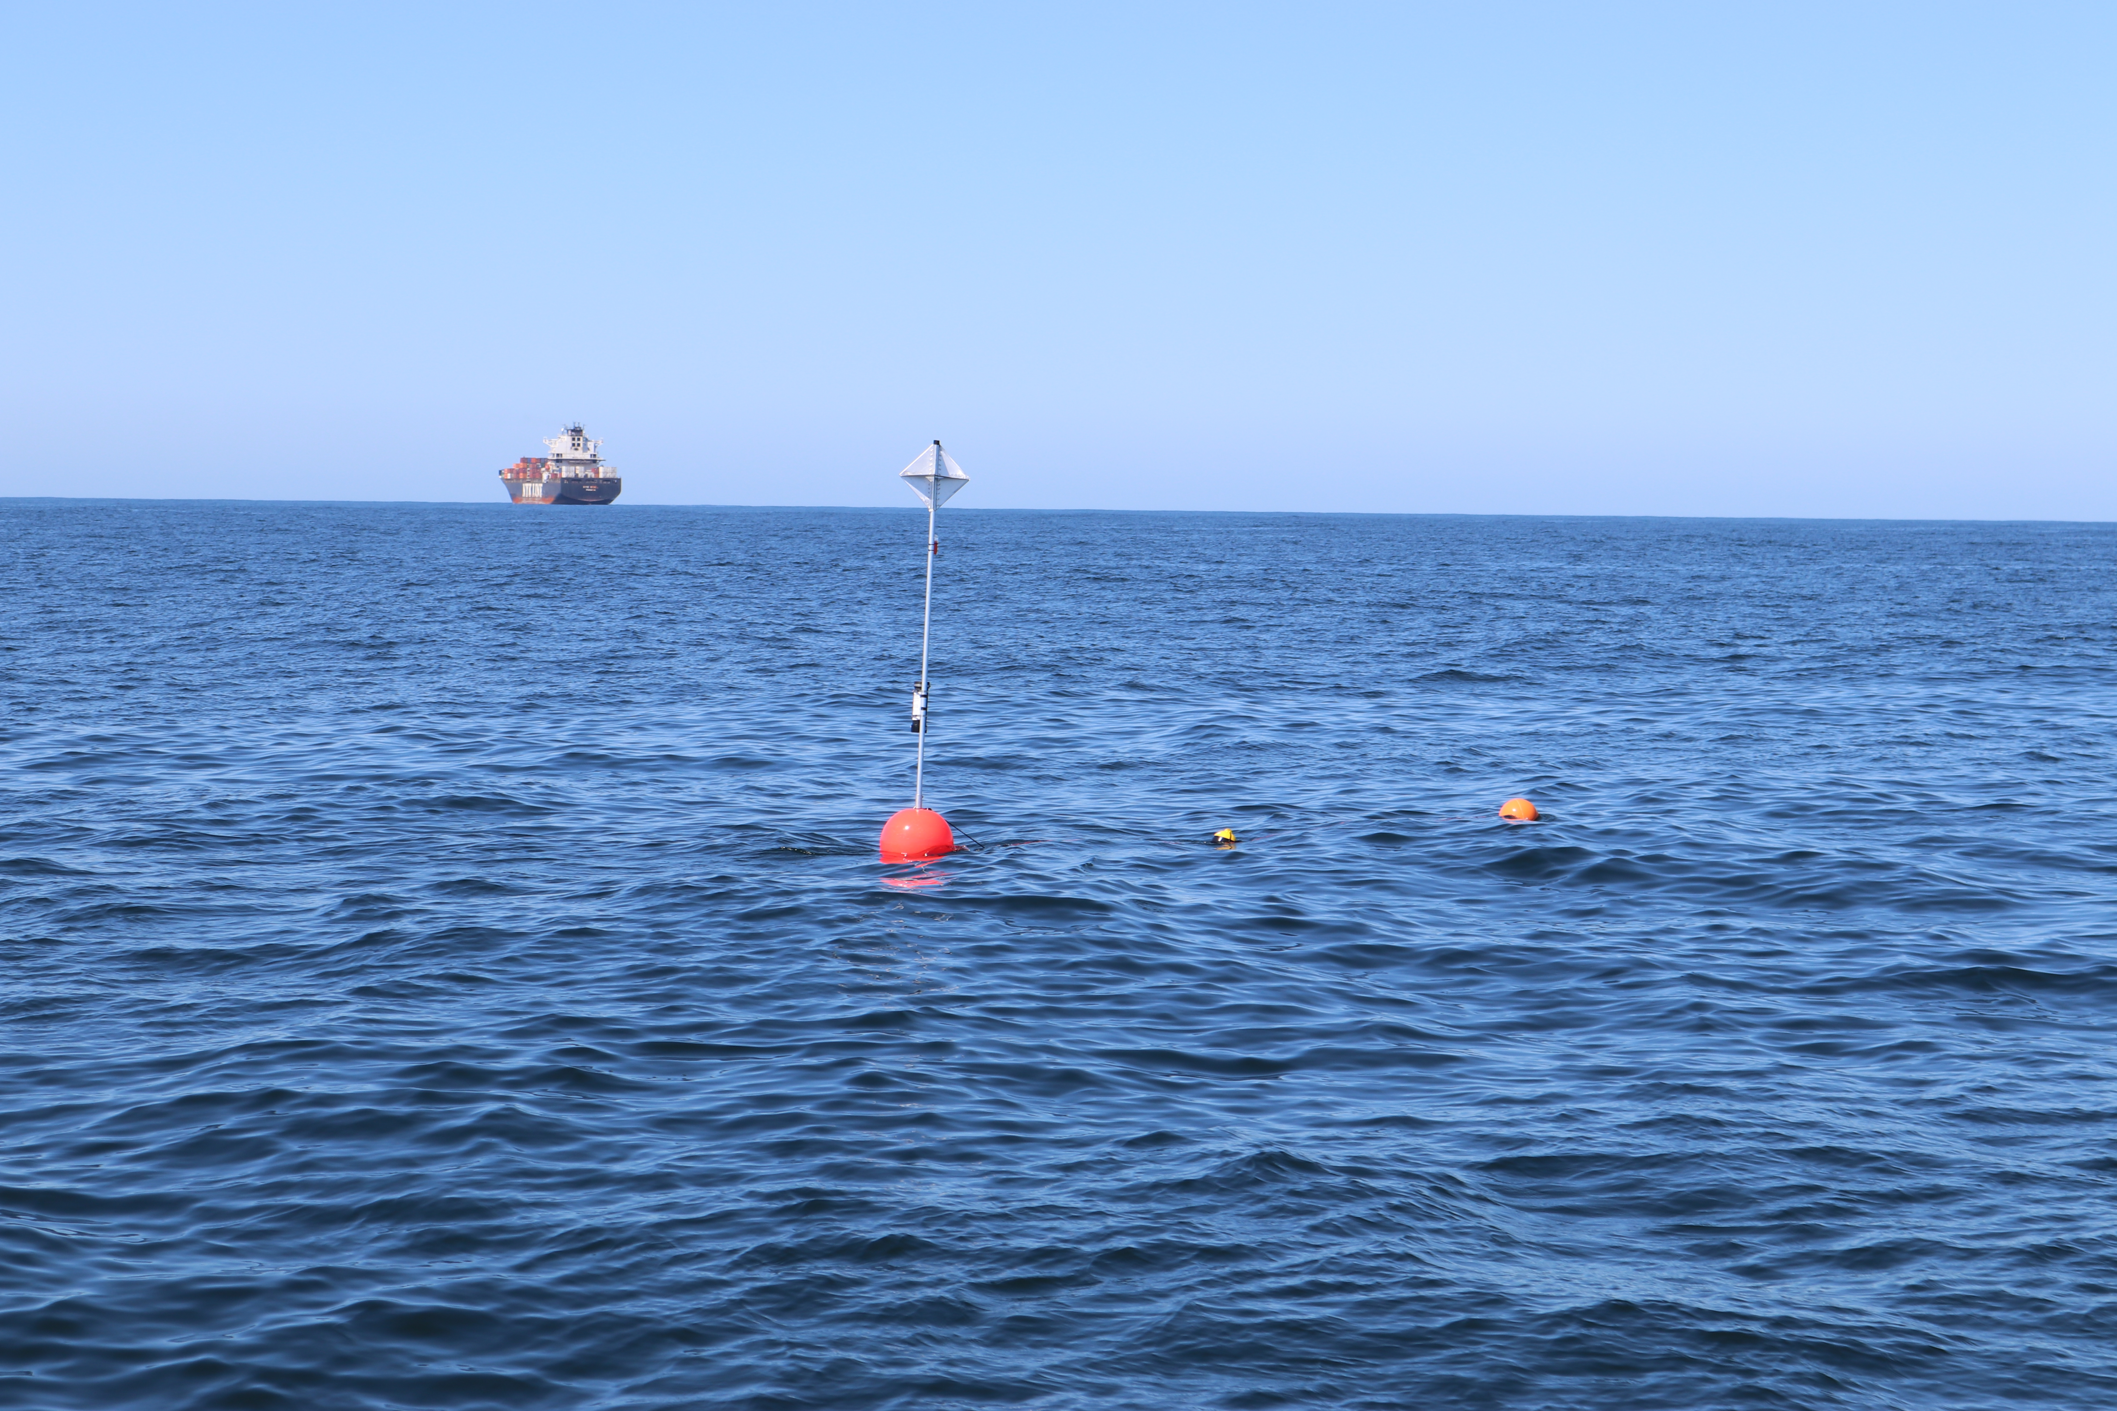](https://github.com/shannonrankin/ADRIFT_Report/blob/main/figs/drifterShip_Rankin_SWFSC_ACCESS_2021_MULTI-2019-005.JPG)

ADRIFT-ACCESS in the Greater Farallones and Cordell Bank Sanctuary: Passive Acoustic Monitoring in the California Current using Drifting Recorders

October, 2024

Authors:

Shannon Rankin

Anne Simonis

Kourtney Burger

Cory Hom-Weaver

Kaitlin Palmer

Taiki Sakai

Southwest Fisheries Science Center

NOAA Fisheries

8901 La Jolla Shores Dr. La Jolla, CA 92037

**CITATION**

Rankin, S., Burger, K., Hom-Weaver, C., Palmer, K., Sakai, T., Simonis, A. (Southwest Fisheries Science Center, NOAA Fisheries, La Jolla, CA). 2024. Final Report for ADRIFT-ACCESS in the Greater Farallones and Cordell Bank Sanctuary: Passive Acoustic Monitoring in using Drifting Recorders. Camarillo (CA): NOAA Technical Memorandum [xxyy]

**ABOUT THE COVER**

A drifting acoustic recorder floats offshore San Francisco with a large container ship in the background. Photo Credit Shannon Rankin, Southwest Fisheries Science Center, NOAA Fisheries.

**ACKNOWLEDGMENTS**

This project benefited from a large number of partnerships with external organizations, including: San Francisco State University (Marina Bozinovic, Jackson Vanfleet Brown), Moss Landing Marine Labs (Jack Barkowski, Alison Stimpert), National Marine Sanctuary Foundation (Lindsey Peavey, Erin Jaszczak, Cassandra Erickson), Greater Farallones National Marine Sanctuary (Jan Roletto), Cordell Bank National Marine Sanctuaries (Dani Lipski), NOAA's Ocean Acoustics Program (Jason Gedamke). We also thank the captain and crew of the R/V *Shearwater* and the R/V *Fulmar*.

This study was funded in part by the U.S. Department of the Interior, Bureau of Ocean Energy Management through Interagency Agreement M20PG00013 with the U.S. Department of Commerce, National Oceanic and Atmospheric Administration, National Marine Fisheries Service (NMFS), Southwest Fisheries Science Center (SWFSC).

Contents

List of Figures v

List of Tables vii

List of Abbreviations and Acronyms viii

Background 9

Methods 10

Soundscape 13

Results 14

Marine Mammal Detections 17

Sperm Whales 17

Beaked Whales 18

Dolphins 19

Narrow Band High Frequency Species (*Kogia* spp., porpoise) 20

Blue Whales 22

Fin Whales 23

Humpback Whales 25

Bryde’s and Sei Whales 26

Gray Whales 27

Minke Whales 28

Soundscape 28

Power Spectral Density 28

Ship Noise 29

Contributors to the Soundscape 31

Data Sharing 33

Education and Outreach 33

Conclusions and Future Directions 36

2. Summary of Results 37

Recommendations 41

Data Collection Recommendations 41

Data Analysis and Archive Recommendations 41

3. References 43

Appendix A. Adrift Expanded Datasets 47

# List of Figures

Figure 1. Diagram of drifting recorders used in the Adrift project. 12

Figure 2. Plot of all successful drifts deployed in the San Francisco region during the Adrift project. Drifts deployed during upwelling are green, and post-upwelling are yellow. Wind Energy Areas are outlined in purple, and shipping lanes for entry to San Francisco Bay are outlined in yellow. 17

Figure 3. Hourly sperm whale events by month for Adrift-ACCESS surveys. Hourly sperm whale events (y axis) for different months for combined years (x axis) during the Adrift-ACCESS surveys. Hourly presence for duty-cycled data relates to the portion of the hour included in the duty cycled data. Black lines represent total available hours (effort) and red lines represent hours with detections. Blue shading represents winter, green represents upwelling, and yellow represents the post-upwelling oceanographic season. 20

Figure 4. Hourly goose-beaked whales and Baird's beaked whales by month for the Adrift-ACCESS surveys. Hourly presence of goose-beaked whales (left) and Baird's beaked whales (right) (y axis) for different months for combined years (x axis) during the Adrift-ACCESS surveys. Hourly presence for duty-cycled data relates to the portion of the hour included in the duty cycled data. Black lines represent total available hours (effort) and red lines represent hours with detections. Blue shading represents winter, green represents upwelling, and yellow represents the post-upwelling oceanographic season. 21

Figure 5. Hourly dolphin events by month for Adrift-ACCES surveys. Hourly presence of dolphins (combined species) (y axis) for different months for combined years (x axis) during the Adrift-ACCESS surveys. Hourly presence for duty-cycled data relates to the portion of the hour included in the duty cycled data. Black lines represent total available hours (effort) and red lines represent hours with detections. Blue shading represents winter, green represents upwelling, and yellow represents the post-upwelling oceanographic season. 22

Figure 6. Hourly Risso’s and Pacific white-sided dolphins by month for the Adrift-ACCESS surveys. 23

Figure 7. Hourly NBHF events by month for the Adrift-ACCESS surveys. Hourly presence of NBHF events (y axis) for different months for different months for combined years (x axis) during the Adrift-ACCESS surveys. Hourly presence for duty-cycled data relates to the portion of the hour included in the duty cycled data. Black lines represent total available hours (effort) and red lines represent hours with detections. Blue shading represents winter, green represents upwelling, and yellow represents the post-upwelling oceanographic season. 24

Figure 8. Hourly blue whale events by month for the Adrift-ACCESS surveys. Hourly presence of blue whale calls (A, B, and D types, combined) (y axis) for different months for combined years (x axis) during the Adrift-ACCESS surveys. Hourly presence for duty-cycled data relates to the portion of the hour included in the duty cycled data. Black lines represent total available hours (effort) and red lines represent hours with detections. Blue shading represents winter, green represents upwelling, and yellow represents the post-upwelling oceanographic season. 25

Figure 9. Hourly presence of blue whale D calls by month for the Adrift-ACCESS surveys. Hourly presence of blue whale D calls (y axis) for different months for combined years (x axis) during the Adrift-ACCESS surveys. Adrifts 001-012 were duty cycled and hourly presence relates to the portion of the hour included in the duty cycled data (6 min of 12 min). Black lines represent total available hours (effort) and red lines represent hours with detections. Blue shading represents winter, green represents upwelling, and yellow represents the post-upwelling oceanographic season. 26

Figure 10. Hourly fin whale events by month for the Adrift-ACCESS surveys. Hourly presence of fin whales (combined call types) (y axis) for different months for combined years (x axis) during the Adrift-ACCESS surveys. Hourly presence for duty-cycled data relates to the portion of the hour included in the duty cycled data. Black lines represent total available hours (effort) and red lines represent hours with detections. Blue shading represents winter, green represents upwelling, and yellow represents the post-upwelling oceanographic season. 27

Figure 11. Hourly humpback whale events by month for the Adrift-ACCESS surveys. Hourly presence of combined humpback whales call types (y axis) for different months for combined years (x axis) during the Adrift-ACCESS surveys. Hourly presence for duty-cycled data relates to the portion of the hour included in the duty cycled data. Black lines represent total available hours (effort) and red lines represent hours with detections. Blue shading represents winter, green represents upwelling, and yellow represents the post-upwelling oceanographic season. 28

Figure 12. Hourly presence of humpback song, social calls by month for the Adrift-ACCESS surveys. Hourly presence of humpback song (left) and humpback social calls (right)(y axis) for different months for combined years (x axis) during the Adrift-ACCESS surveys. Adrifts 001-012 were duty cycled and hourly presence relates to the portion of the hour included in the duty cycled data (6 min of 12 min). Black lines represent total available hours (effort) and red lines represent hours with detections. Blue shading represents winter, green represents upwelling, and yellow represents the post-upwelling oceanographic season. 29

Figure 13. Hourly gray whale events by month for the Adrift-ACCESS surveys. Hourly presence of gray whale calls (y axis) for different months for combined years (x axis) during the Adrift-ACCESS surveys. Hourly presence for duty-cycled data relates to the portion of the hour included in the duty cycled data. Black lines represent total available hours (effort) and red lines represent hours with detections. Blue shading represents winter, green represents upwelling, and yellow represents the post-upwelling oceanographic season. 30

Figure 14. Power spectral density for Adrift deployments by season and region. 32

Figure 15. Polar plots of seasonal detection of ship noise in the Adrift-ACCESS surveys. The hourly percent of effort with vessel detections is shown in color ranging from dark blue (0%) to yellow (50%). The diurnal variation in vessel noise is shown by detection in bins on polar plot ranging from 0 to 24 hr of the day (UTC, Universal Time Coordinated). 33

Figure 16. Acoustic scene for San Francisco, 2021. Acoustic scene showing detections of various contributors to the soundscape for the 2021 San Francisco deployments in the upwelling and post-upwelling oceanographic seasons. 34

Figure 17. Acoustic scene for San Francisco, 2022. Acoustic scene showing detections of various contributors to the soundscape for the 2022 San Francisco deployments in the upwelling and post-upwelling oceanographic seasons. 35

Figure 18. Acoustic scene for San Francisco, 2023. Acoustic scene showing detections of various contributors to the soundscape for the 2023 San Francisco deployments in the upwelling and post-upwelling oceanographic seasons. 35

# List of Tables

Table 1. Summary of deployments during Adrift-ACCESS surveys. 18

Table 2. Summary of sperm whale detections for regular and slow clicks in hourly bins for Adrift-ACCESS surveys. 19

Table 3. Summary of beaked whale detections Baird’s beaked whales and goose-beaked whales in hourly bins for Adrift-ACCESS data. 20

Table 4. Summary of dolphin detections (by species) in hourly bins for Adrift-ACCESS data. 21

Table 5. Summary of NBHF detections in hourly bins for Adrift-ACCESS data. 23

Table 6. Summary of blue whale detections in hourly bins for Adrift data. 25

Table 7. Summary of fin whale detections in hourly bins for Adrift-ACCESS data. 26

Table 8. Summary of humpback whale detections in hourly bins for Adrift-ACCESS data. 28

Table 9. Summary of gray whale detections in hourly bins for Adrift-ACCESS data. 30

Table A‑1. Summary of Adrift deployments. 50

# List of Abbreviations and Acronyms

|  |  |
| --- | --- |
| ACCESS | Applied California Current Ecosystem Studies |
| Bb | *Berardius bairdii* |
| BOEM | Bureau of Ocean Energy Management |
| BWC | Cross Seamount Beaked Whale |
| BW43 | *Mesoplodon ginkgodens* (Beaked Whale 43 kHz) |
| CCES | California Current Ecosystem Survey |
| FFT | Fast Fourier Transform |
| GPL | Generalized Power Law |
| GUI | Graphical User Interface |
| HUM | Humboldt |
| ICI | Inter-Click Interval |
| IPI | Inter-Pulse Interval |
| K.spp. | *Kogia* species (*K. breviceps* and *K. simus*) |
| LTSA | Long Term Spectral Average |
| NBHF | Narrow Band High Frequency |
| NCEI | National Center for Environmental Information |
| NOAA | National Oceanographic and Atmospheric Administration |
| NMFS | National Marine Fisheries Service |
| PACM | Passive Acoustic Cetacean Map |
| PAM | Passive Acoustic Monitoring |
| RoboJ | Robotic Jay |
| SFSU | San Francisco State University |
| SNR | Signal to Noise Ratio |
| SR | Sample Rate |
| SWFSC | Southwest Fisheries Science Center |
| UC | University of California |
| US | United States (of America) |
| UTC | Universal Time Coordinated |
| WEA | Wind Energy Area |

# Background

Cetacean distribution and abundance data are traditionally collected by large vessels and aircraft conducting surveys in offshore areas. These surveys provide important data, but due to the expense and difficulty in collecting data during bad weather or during times of low visibility, these surveys are generally conducted intermittently during the summer and fall seasons. As such, these data suffer from spatial and temporal gaps, especially for cryptic species. Since sound is the primary sensory modality of marine mammals, passive acoustic monitoring (PAM) is an efficient approach to monitoring marine mammals as well as simultaneous characterization of the overall soundscape.

There are a variety of PAM platforms that vary in strengths and limitations: towing hydrophones behind a ship provides good geographic resolution, while seafloor hydrophones allow for good temporal resolution. Passive acoustic drifting recorders can record for days to weeks or months (depending on recording characteristics and local currents) and their low cost allows for deployment of multiple instruments, which increases spatial coverage and provides a model for intermediate geographic and temporal resolution. Furthermore, the hydrophones for drifting recorders can be positioned near animals in the water column (and away from surface noise), which allows them to collect high-quality data without affecting animal behavior. Drifting recorders have been increasingly deployed during large scale shipboard surveys to augment visual line-transect surveys for cryptic and deep-diving species (Keating et al. 2018; Simonis 2020), and methods have been developed to estimate density and abundance of goose-beaked whales (*Ziphius cavirostris*) (Barlow et al. 2021). As drifting recorders are not tethered to the seafloor or to a ship, they have shown potential as an alternative PAM platform for the wind energy areas identified in the deep waters offshore the U.S. West Coast.

The goal of the Adrift in the California Current Project ('Adrift') was to use passive acoustic drifting recorders deployed offshore the U.S. West Coast to assess the distribution of marine mammals and to characterize the marine soundscape. This three-year study was initiated in the Northern California region in 2020, was extended to Central California in 2021, and an additional pilot study off Oregon was initiated in 2022. The Applied California Current Ecosystem Studies (ACCESS) surveys provide an opportunity to deploy drifting recorders to monitor the waters offshore San Francisco Bay. This report complements the final [Adrift report](https://sael-swfsc.github.io/Adrift/content/spatialNoise.html) with specific focus on the Adrift-ACCESS data collection efforts within these NOAA Sanctuaries.

Specific objectives of the Adrift-ACCESS surveys include:

* Determine the viability and value of coordinated drifting recorder PAM monitoring during ACCESS Surveys
* Identify marine mammal species encountered within the Greater Farallones and Cordell Bank National Marine Sanctuaries
* Provide additional information on the detection of fin and blue whales within and offshore the Greater Farallones and Cordell Bank National Marine Sanctuary

# Methods

The Adrift project surveyed the California Current between Point Conception to the south and Newport, Oregon to the north. The primary focal regions included areas of importance to the initial phases of offshore renewable wind energy development, including two locations in Oregon (Coos Bay to the North, and Brookings to the South), Humboldt, and Morro Bay.

The Adrift project partnered with the Greater Farallones and the Cordell Bank National Marine Sanctuaries and Point Blue to participate in their tri-annual Applied California Current Ecosystem Studies (ACCESS) surveys. These surveys provided an opportunity to deploy and retrieve 1-2 drifting recorders in the area offshore San Francisco Bay, providing data to inform the Sanctuaries and to provide an additional dataset between the Morro Bay and Humboldt WEAs. Seasonal variation considered the oceanographic seasons designated in (Southall et al. 2023): upwelling (March - June), post-upwelling (July - November), and winter (December - February). ACCESS surveys are conducted in late spring through late summer, during the upwelling and post-upwelling oceanographic seasons.

Drifting recorders consist of a hydrophone array and autonomous recorder at depth with a surface buoy and satellite GPS at the surface to allow for tracking and retrieval (Figure 1).

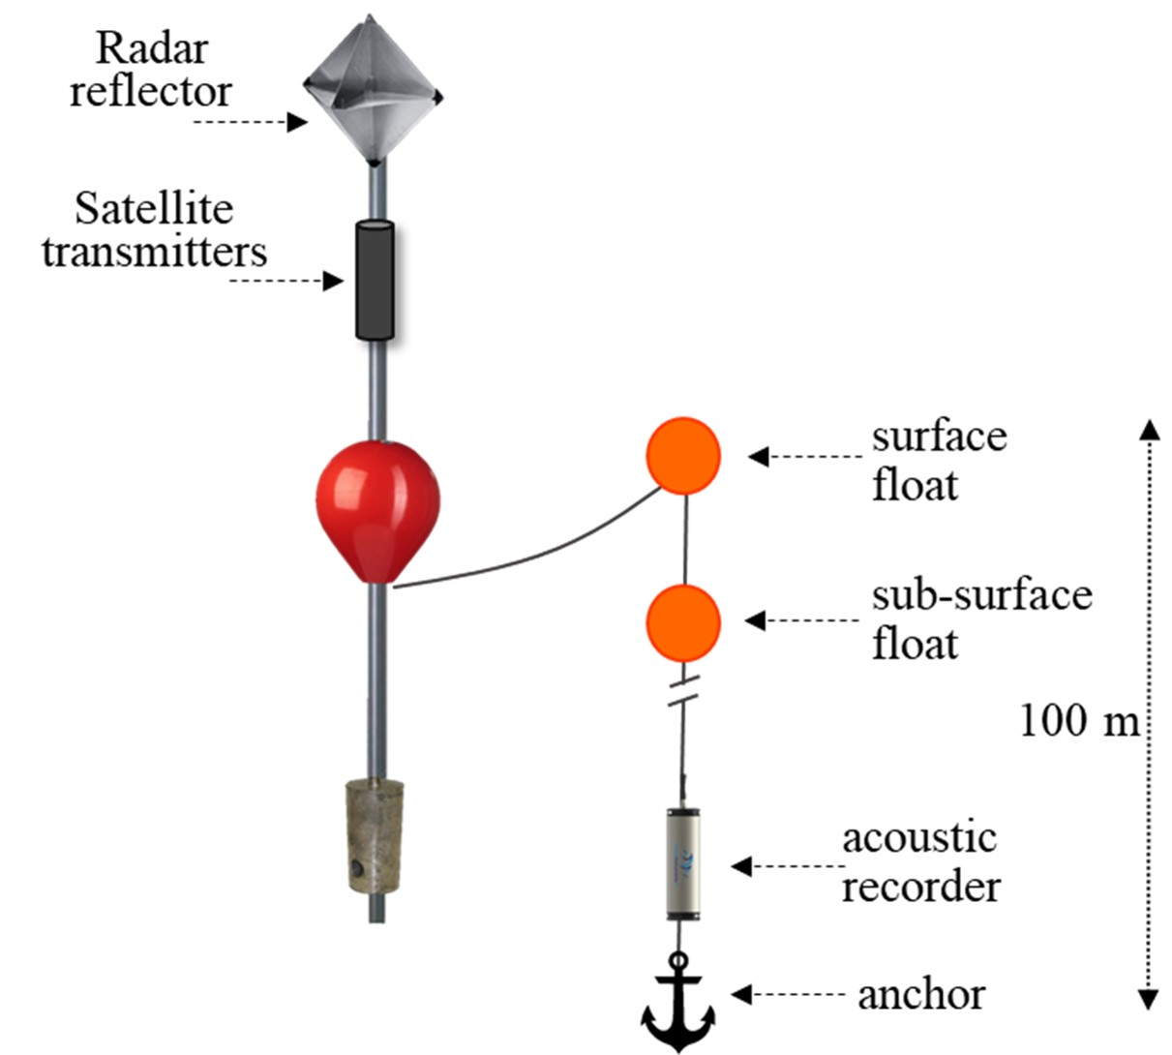

Figure 1. Diagram of drifting recorders used in the Adrift project.

The hydrophone array, recorder, and ancillary components were deployed vertically from the surface trawl float, with the hydrophone array and recorder located 100 or 150 m depth. The acoustic recording equipment consisted of a two-element vertical hydrophone array below the recorder. The top hydrophone consisted of an HTI-92WB and the lower hydrophone consisted of an HTI-96min positioned 5m below the top hydrophone. Recorders consisted of either the (now discontinued) SoundTrap 4300 or the SoundTrap 640 which allowed for extended deployments (Ocean Instruments, NZ). The anchor was attached below the hydrophone array using a small rope with low breaking strength as a 'weak-link' to mitigate entanglement risk.

Initial recordings included a duty cycle to extend deployment, and then all recordings shifted to continuous sampling. Sample rate varied according to the instrument, with a minimum sample rate of 288 kHz. A summary of deployment details can be found in Appendix: Adrift Expanded Datasets and in the [Adrift website](https://sael-swfsc.github.io/Adrift/content/driftingRecorders.html).

Prior to analysis, data files stored on the SoundTrap recorders were downloaded, extracted, and decimated to 500Hz, 12 kHz, and 48 kHz. A series of full bandwidth Long Term Spectra Averages (LTSAs) were generated using Triton software with 200 Hz, 5 s resolution. LTSAs were then scanned to assess overall data quality and to identify recording data start and end times. A series of custom quality assurance and quality control functions provided a check for appropriate time format, eliminated spurious GPS tracks, and identified unexpected recording gaps. More information on pre-processing methods can be found on [GitHub](https://sael-swfsc.github.io/adrift-analysis-methods/content/DataArchive/DataPrep.html).

A primary goal of the Adrift-ACCESS project was to identify which marine mammal species frequent the Greater Farallones and Cordell Bank National Marine Sanctuaries, and to describe their seasonal occurrence and distribution within the greater California Current Ecosystem. Different call types are understood to be associated with specific behaviors and therefore provide information related to habitat use. For mysticete (baleen) whales, we focused on blue whales (*Balaenoptera musculus*), fin whales (*B. physalus*), Bryde’s whales (*B. edeni*), sei whales (*B. borealis*), humpback whales (*Megaptera novaeangliae*), gray whale (*Eschrichtius robustus*) and minke whales (*B. acutorostrata*). For odontocetes (toothed whales), we focused on sperm whales (*Physeter macrocephalus*), beaked whales (all regional species), dolphins (including Risso’s dolphins, *Grampus griseus*, and Pacific white-sided dolphins, *Lagenorhynchus obliquidens*), and narrow band high frequency (NBHF) species (harbor porpoise, *Phoceona phocoena*, Dall’s porpoise, *Phocoenoides dalli*, and *Kogia* spp.).

Raw recording data were processed and analyzed to detect the presence of calls associated with these species, with different analysis methods for different species. Detection of sounds were noted in hourly bins; and detection methods varied by species. Analysis was not conducted on recordings deemed unusable due to excessive self-noise. Additional details can be found in our [Github analysis methods](https://sael-swfsc.github.io/adrift-analysis-methods).

**Sperm Whales.** An experienced analyst manually scanned 1 hr LTSA windows created with 48 kHz decimated data to identify the start and end times of sperm whale encounters. An encounter was defined as a series of clicks separated by no more than 30 min from other clicks. When potential sperm whale clicks were identified in the LTSA, 10 s spectrograms were used to confirm species identification. Opportunistic detections of slow clicks (lower frequency emphasis at 2-4 kHz, longer inter-click interval, ICI) associated with adult males were also logged.

**Beaked Whales.** Multiple click detectors were run on 288 kHz decimated data using [PAMGuard](http://pamguard.org/) (v.2.02.09f). The Click Template Classification module in PAMGuard was used to assign correlation scores to click templates from the following click types: goose-beaked whales, Baird's beaked whales (*Berardius bairdii*), Blainville's beaked whales (*Mesoplodon densirostris*), Stejneger's beaked whales (*M. stejnegeri*), Hubb's beaked whales (*M. carlhubbsi*, formerly BW37V), Cross Seamount Beaked Whale (BWC), and unidentified beaked whale BW43 (BW43, recently identified as *M. ginkgodens* (Henderson et al., *in prep.*)). All potential beaked whale events and species identifications were manually corrected by an analyst by reviewing detection and event features in PAMGuard.

**Dolphins.** An experienced analyst manually scanned 1 hr LTSA windows to identify the start and end times of dolphin acoustic events. The analyst noted the presence of different click types to identify Risso's dolphins and Pacific white-sided dolphins within these events (Soldevilla et al. 2008). Some dolphin species produce echolocation clicks which cannot currently be classified from the LTSA; those species are not included in this analysis, but their presence may be identified by the detection of dolphin whistle events. Dolphin whistles appear in the LTSA as scattered, yet distinct pockets of energy between 2 and 20 kHz. There are no established methods to identify dolphin species by their whistles in the LTSA alone; therefore, dolphin whistle events are all attributed to "Unidentified Odontocetes".

**Narrow Band High Frequency Species** (*Kogia* spp., porpoise). A NBHF click detector was run on full bandwidth data using PAMGuard (v2.02.09). Potential NBHF acoustic events are automatically defined based on the presence of 3 or more clicks that exceed matched-template thresholds that occur within a 2-minute period. All NBHF events are confirmed by an analyst by reviewing detection and event features in the Click Display window of PAMGuard Viewer.

**Blue Whales.** Detection of blue whale A, B, and D calls were identified by an experienced analyst scanning hourly LTSA windows. Detection of at least one call of any call type (A, B, or D) was required to determine presence of blue whales in hourly bins. Deployments with excessive self-noise (such as strumming) that consistently impacted our ability to detect blue whales were eliminated from this analysis.

**Fin Whales.** Due to complications associated with fin whale call structure, we implemented multiple methods to detect fin whale 20 and 40 Hz calls. For all datasets, fin whale 20 and 40 Hz calls were analyzed by our research partner OSA using a PAMGuard whistle and moan detector (v2.02.09) and reviewed by an experienced analyst in PAMGuard's Viewer Mode. Detections were grouped into acoustic events using the Detection Group Localiser module. Acoustic events were then binned into hourly presence for the 40 Hz fin whale call type.

Fin whale 20 Hz calls were also detected using the click detector in PAMGuard (v2.02.09). A stratified sub-sampling method was used to validate 20% of the wav files in each drift. A random forest model was developed using validated data from 14 drifts from three different geographic areas between 2021-2023. This model was used to predict the presence of fin whales in hourly bins. For each hourly bin, if there were less than 3 predictions with scores over 0.5, these classifications were automatically rejected to eliminate false positives. Hourly bins with at least 3 predictions with scores greater than 0.5 were manually reviewed by an experienced analyst for final classification.

**Humpback Whales.** An experienced analyst manually scanned spectrograms of 12 kHz decimated data to detect the presence of humpback whale calls. Humpback whale calls were categorized as song, social, or undetermined calls. Cross validation of a portion of calls was completed with Dr. Alison Stimpert to ensure consistency with expert annotations.

**Bryde’s and Sei Whales.** Detection of calls associated with Bryde’s and sei whales was conducted by our partners at OSA; a whistle and moan detector was used to detect calls associated with Bryde's (Be4) and sei whales (frequency modulated downsweep calls identified in Rankin and Barlow (2007)). Potential calls were reviewed by an experienced OSA analyst in PAMGuard's Viewer Mode. Detections were grouped into acoustic events using the Detection Group Localiser module. Acoustic events were then binned into hourly presence for the presence of Bryde's and sei whales. Deployments with excessive self-noise (such as strumming) that consistently impacted our ability to detect Bryde's and sei whales were eliminated from this analysis.

**Gray Whales.** An experienced analyst manually scanned spectrograms of 12 kHz decimated data to detect calls associated with gray whales. Presence of gray whales were indicated, but call classes were not specified. Cross validation of a portion of calls was verified by Dr. Alison Stimpert to ensure consistency with expert annotations.

## Soundscape

**Power Spectral Density.** Soundscape metrics aligned with [SanctSound protocols](https://sanctsound.ioos.us) and were measured using Triton (Wiggins and Hildebrand 2007) with the Soundscape Remora. Data were decimated to 48 kHz, and LTSAs were calculated with a 1 Hz, 1 s resolution. The full system calibration value was calculated from the combined hydrophone and SoundTrap sensitivity. Soundscape LTSAs were used to calculate sound levels in 2-minute windows from 100 - 24,000 Hz, including broadband sound pressure levels, third-octave levels, and power spectral densities. Median (50th percentile), mean, and various statistical sound levels (1st, 5th, 10th, 25th, 75th, 90th, and 95th percentiles) are calculated for each metric.

**Ship Noise.** Vessel noise was identified by a trained analyst scanning 1-hour LTSA windows using the Logger Remora in Triton and 10 s spectrograms were used to confirm identification. Ships were either logged as being broadband (high amplitude with frequency content above 5 kHz) or narrowband/low frequency (lower amplitude).

**Contributors to the Soundscape.** Temporal variation (marked in hourly bins) in the contribution of these sounds to the overall soundscape are provided by the acoustic scene. An acoustic scene provides a visualization of the spectral variation in the contributors to the soundscape, where detection of various species classes is noted by the approximate frequency of their sounds. For this visualization, we used the following frequency range for these detections: blue whale (15 - 25 Hz), fin whale (20 - 50 Hz), humpback whale (50 - 2,000 Hz), sei whale (50 - 500 Hz), gray whale (100 - 2,000 Hz), minke whale (1,000 -2,000 Hz), sperm whale (1,000 - 20,000 Hz), dolphins (1,000 - 25,000 Hz), beaked whales (25,000 - 60,000 Hz), NBHF species (80,000 - 120,000 Hz) and ship noise (100 - 1,000 Hz).

# Results

A total of 17 drifting recorders were deployed during ACCESS were conducted during the upwelling and post-upwelling oceanographic seasons (Figure 2, Table 1). Deployments in the post-upwelling season extended further south than deployments in the upwelling season (Figure 2); these geographic differences may contribute to seasonal differences in marine mammal detections.

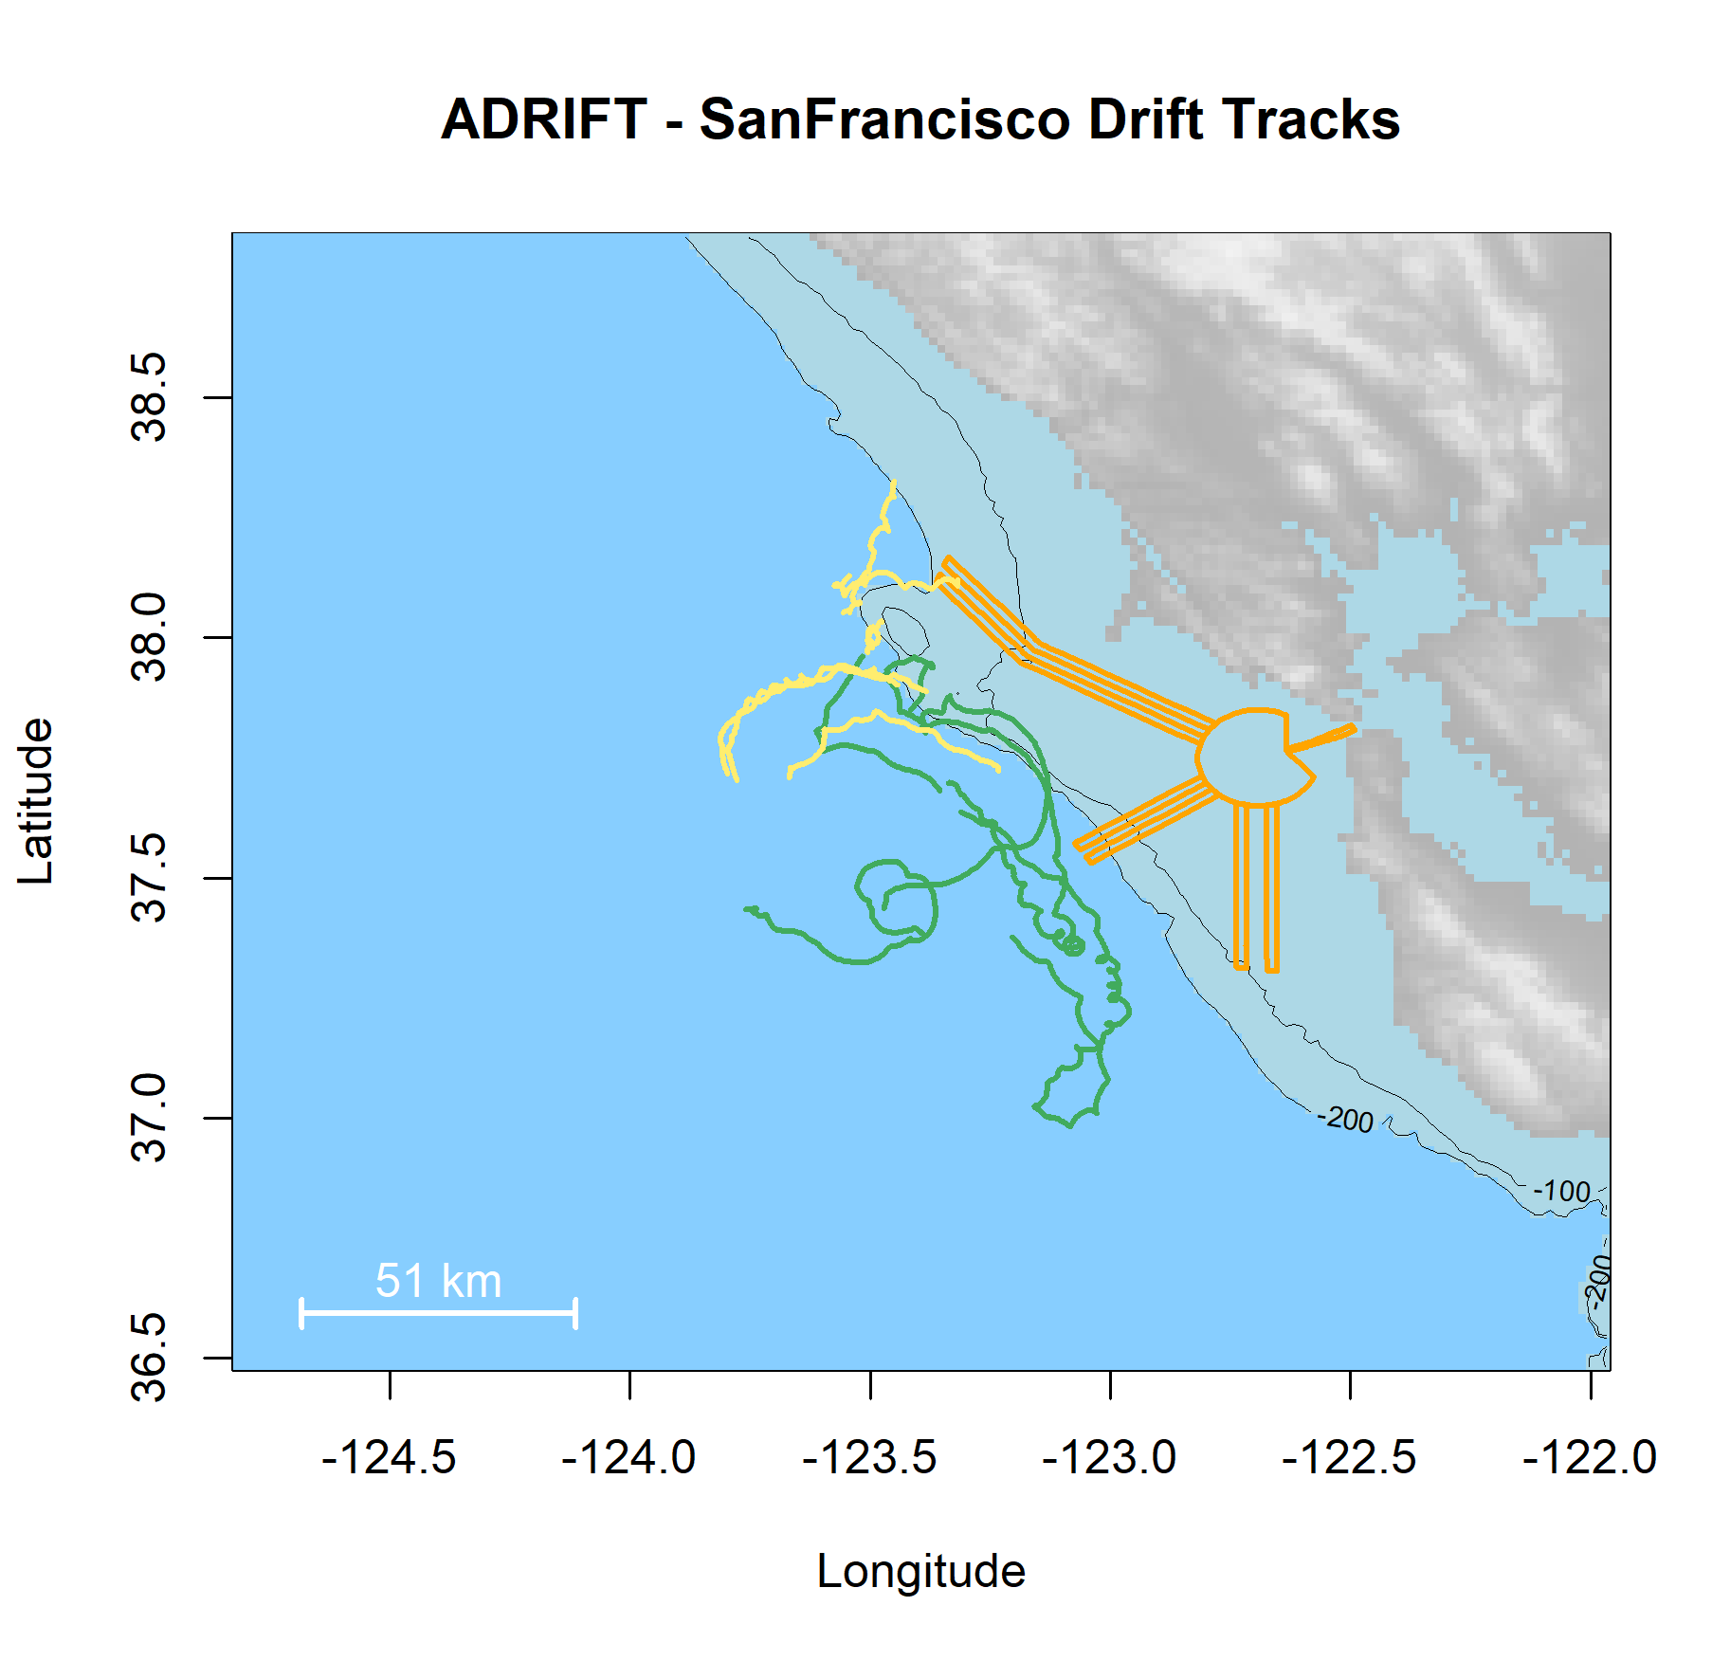

Figure . Plot of all successful drifts deployed in the San Francisco region during the Adrift project. Drifts deployed during upwelling are green, and post-upwelling are yellow. Wind Energy Areas are outlined in purple, and shipping lanes for entry to San Francisco Bay are outlined in yellow.

Drifting acoustic recorders contain instrumentation at depth, and are not appropriate for use on the continental shelf. All drifting recorders were deployed in waters greater than 200m depth; however, some drifts traveled into shallow waters and two drifting recorders grounded on/near Cordell Bank (ADRIFT-003, ADRIFT-035). Seafloor recorders should be used for nearshore monitoring in depths less than 300 m.

There were multiple cases of equipment (lost/sunk in Table 1) and data loss (unusable in Table 1), especially during the initial deployments. Losses were due to a variety of reasons, including inclement weather, strong currents, and recorder failures. We mitigated these problems through modifying components and altering survey methods. Some data were compromised due to strumming of the rope/cable; most of these cases led to interference at low frequencies and may affect usability of recording to detect fin and blue whales. Additional deployment details are provided in Table A‑1. (Summary of Adrift deployments) and on the [Adrift Website](https://sael-swfsc.github.io/Adrift/content/driftingRecorders.html).

Table . Summary of deployments during Adrift-ACCESS surveys.

|  |  |  |  |  |  |  |
| --- | --- | --- | --- | --- | --- | --- |
| **Deployment ID** | **Status** | **Deployment Latitude** | **Deployment Longitude** | **Deployment Date** | **Recovery Date** | **Quality Category** |
| ADRIFT_002 | Complete | 37.3845 | -122.3910 | 6/9/2021 | 6/29/2021 | compromised |
| ADRIFT_003 | Complete | 37.9659 | -123.5041 | 7/25/2021 | 8/3/2021 | compromised |
| ADRIFT_005 | Complete | 37.6401 | -123.3170 | 6/10/2021 | 6/24/2021 | compromised |
| ADRIFT_006 | Complete | 38.1293 | -123.5415 | 7/25/2021 | 7/28/2021 | compromised |
| ADRIFT_007 | Complete | 37.8435 | -123.4218 | 6/10/2021 | 6/24/2021 | compromised |
| ADRIFT_008 | Lost | 37.1371 | -122.9643 | 6/9/2021 | NA | unusable |
| ADRIFT_010 | Sunk | 37.8039 | -123.3891 | 9/25/2021 | 10/14/2021 | unusable |
| ADRIFT_011 | Sunk | 37.6407 | -123.1331 | 9/25/2021 | 10/15/2021 | unusable |
| ADRIFT_015 | Complete | 37.9643 | -123.5039 | 6/18/2022 | 6/21/2022 | compromised |
| ADRIFT_016 | Unusable | 37.8012 | -123.3849 | 6/16/2022 | 6/21/2022 | unusable |
| ADRIFT_027 | Complete | 37.9012 | -123.4428 | 7/26/2022 | 7/30/2022 | good |
| ADRIFT_028 | Complete | 37.8875 | -123.3764 | 7/26/2022 | 7/30/2022 | good |
| ADRIFT_034 | Complete | 38.0475 | -123.5617 | 9/27/2022 | 10/1/2022 | good |
| ADRIFT_035 | Unusable | 38.1304 | -123.5300 | 9/26/2022 | 10/1/2022 | unusable |
| ADRIFT_066 | Unusable | 37.7221 | -123.2327 | 5/8/2023 | 5/13/2023 | unusable |
| ADRIFT_067 | Complete | 37.8012 | -123.3849 | 5/8/2023 | 5/12/2023 | compromised |
| ADRIFT_092 | Complete | 37.7225 | -123.2325 | 9/17/2023 | 9/22/2023 | compromised |

## Marine Mammal Detections

A primary goal of the Adrift-ACCESS project was to identify which marine mammal species frequent the Greater Farallones and Cordell Bank National Marine Sanctuaries, and to describe their seasonal occurrence and distribution within the greater California Current Ecosystem. Different call types are understood to be associated with specific behaviors and therefore provide information related to habitat use. Passive acoustic monitoring relies on sounds produced by animals for detection, and therefore PAM studies cannot identify the absence of animals.



### Sperm Whales

Sperm whales were detected during ACCESS surveys in all months except late September/early October (Figure 3). Most sperm whale detections were ‘regular’ clicks associated with feeding animals; ‘slow’ clicks (associated with adult males) were uncommon but detected in all regions except Morro Bay (Table 2).

Sperm whales had been documented only 3 times in the waters offshore San Francisco in over 30 years of ACCESS visual surveys (J. Roletto, pers. comm.). Our detection of sperm whales (both regular and slow clicks) from drifting recorders deployed during the ACCESS surveys suggests that passive acoustic monitoring might improve our understanding of sperm whale distribution in the busy shipping lanes off San Francisco as well as within the combined Greater Farallones and Cordell Bank National Marine Sanctuary.

Table . Summary of sperm whale detections for regular and slow clicks in hourly bins for Adrift-ACCESS surveys.

|  |  |  |  |
| --- | --- | --- | --- |
|  | **Upwelling** | **Post-Upwelling** | **Winter** |
| **Regular Clicks** | 0.03 (769) | 0.00 (626) | – |
| **Slow Clicks** | 0.01 (769) | 0.00 (626) | – |

Note: Mean hourly probability of sperm whale detection for that call type/season; total hourly bins are shown in parenthesis.

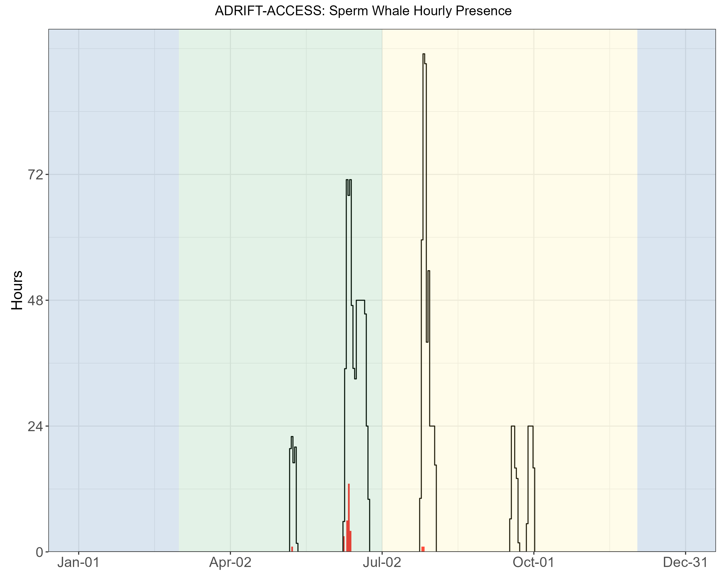

Figure . Hourly sperm whale events by month for Adrift-ACCESS surveys. Hourly sperm whale events (y axis) for different months for combined years (x axis) during the Adrift-ACCESS surveys. Hourly presence for duty-cycled data relates to the portion of the hour included in the duty cycled data. Black lines represent total available hours (effort) and red lines represent hours with detections. Blue shading represents winter, green represents upwelling, and yellow represents the post-upwelling oceanographic season.

A pilot study examining the potential estimation of body size based on inter-pulse and inter-click intervals found that sperm whale groups detected during November deployments in Morro Bay were comprised of females and juvenile males (see [Sperm Whale Demographics summary](https://sael-swfsc.github.io/Adrift/content/spermDemographics.html)).

### Beaked Whales

Baird’s beaked whales and goose-beaked whales were detected in recordings collected during the Adrift-ACCESS surveys (Table 4). Detections of both species were higher during the post-upwelling season, and goose-beaked whales were more commonly detected than Baird’s beaked whales (Table 4).

Table . Summary of beaked whale detections Baird’s beaked whales and goose-beaked whales in hourly bins for Adrift-ACCESS data.

|  |  |  |  |
| --- | --- | --- | --- |
|  | **Upwelling** | **Post-Upwelling** | **Winter** |
| **Baird's beaked whale** | 0.0031 (960) | 0.0176 (688) | – |
| **Goose-beaked whale** | 0.0147 (960) | 0.0250 (688) | – |

Note: Summary of beaked whale detections for Baird’s beaked whales and goose-beaked whales in hourly bins for Adrift-ACCESS data. Mean hourly probability of detection for that species/season; total hourly bins are shown in parenthesis.

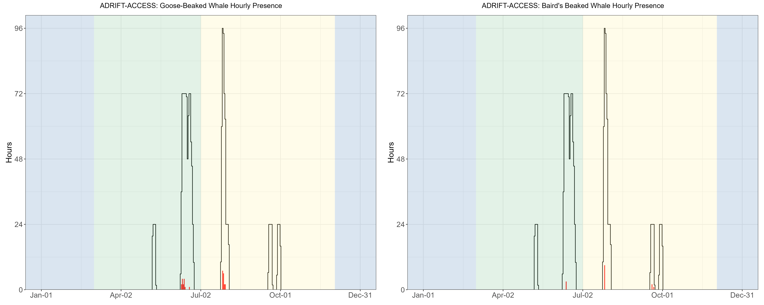

Figure . Hourly goose-beaked whales and Baird's beaked whales by month for the Adrift-ACCESS surveys. Hourly presence of goose-beaked whales (left) and Baird's beaked whales (right) (y axis) for different months for combined years (x axis) during the Adrift-ACCESS surveys. Hourly presence for duty-cycled data relates to the portion of the hour included in the duty cycled data. Black lines represent total available hours (effort) and red lines represent hours with detections. Blue shading represents winter, green represents upwelling, and yellow represents the post-upwelling oceanographic season.

There had been no visual detection of beaked whales during the 30 years of annual ACCESS surveys offshore San Francisco (J. Roletto, pers. comm.). The drifting recorders deployed during the ACCESS surveys detected both Baird's and goose-beaked whales, suggesting that beaked whales do occur in and near the shipping lanes and the combined Greater Farallones and Cordell Bank National Marine Sanctuaries (Figure 5.3). The discrepancy in these detections is likely due to the typically poor sighting conditions in this region and the cryptic surfacing behavior of beaked whales. Future surveys in this region should consider passive acoustic monitoring with sufficient bandwidth to detect echolocating beaked whales.

### Dolphins

Dolphins were detected during all Adrift-ACCESS deployments (Figure 5). Dolphin events included detections that could be positively attributed to Risso's dolphins and Pacific white-sided Dolphins, and detections that remained unidentified (Table 4).

Table . Summary of dolphin detections (by species) in hourly bins for Adrift-ACCESS data.

|  |  |  |  |
| --- | --- | --- | --- |
|  | **Upwelling** | **Post-Upwelling** | **Winter** |
| **Risso's dolphins** | 0.01 (960) | 0.01 (688) | – |
| **Pacific white-sided dolphins** | 0.10 (960) | 0.23 (688) | – |
| **Unidentified odontocetes** | 0.00 (960) | 0.00 (688) | – |

Note: Summary of dolphin detections for Risso’s dolphins, Pacific white-sided dolphins, and unidentified odontocetes for hourly bins for Adrift-ACCESS data. Mean hourly probability of detection for that species/season; total hourly bins are shown in parenthesis.

There were no dolphin events that did not include at least Risso’s or Pacific white-sided dolphins (Table 4). Pacific white-sided dolphins were detected at higher rates than Risso’s dolphins in all but the earliest survey during the upwelling season (Figure 5). Dolphin schools in central and northern California are frequently encountered in large, dispersed mixed species groups (S.Rankin, pers. comm.), and here we do not distinguish mixed species from single-species groups. So, attribution of an acoustic event to Risso's dolphins does not preclude the presence of other species. We currently lack a comprehensive acoustic classification routine that includes all dolphin schools in the region. Future research should develop a publicly available acoustic classifier for dolphins that considers mixed species groups and can be applied to different passive acoustic platforms.

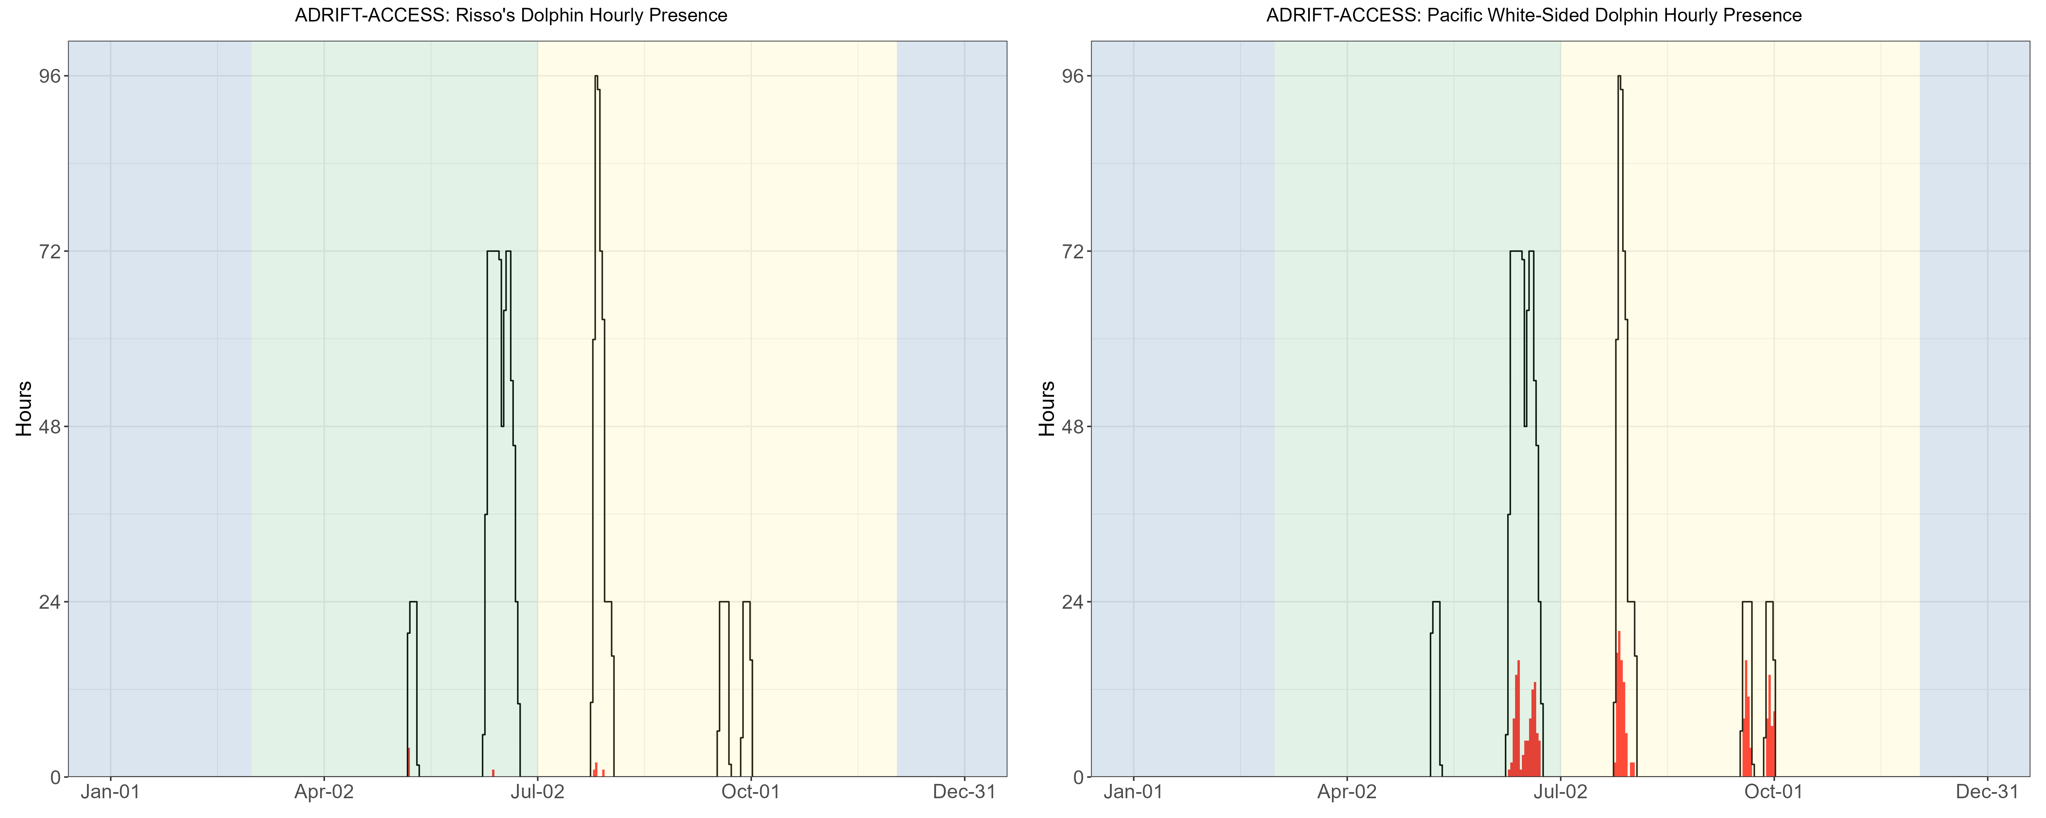

Figure . Hourly Risso’s and Pacific white-sided dolphins by month for the Adrift-ACCESS surveys. Hourly presence of Risso’s dolphins (left) and Pacific white-sided dolphins (right) (y axis) for different months for combined years (x axis) during the Adrift-ACCESS surveys. Hourly presence for duty-cycled data relates to the portion of the hour included in the duty cycled data. Black lines represent total available hours (effort) and red lines represent hours with detections. Blue shading represents winter, green represents upwelling, and yellow represents the post-upwelling oceanographic season.

Risso’s and Pacific white-sided dolphins were detected on most/all ACCESS deployments, and there were most likely other species that were detected but that we could not classify to species. The California Current has a high diversity of dolphin species, and species classification is difficult. Currently, there is insufficient validated data for drifting recorders to test the efficacy of existing classifiers on these data, or to develop a drifting-recorder specific classifier. Adrift data are publicly available for future analysis, should improved acoustic classification methods become available.

### Narrow Band High Frequency Species (*Kogia* spp., porpoise)

Calls associated with NBHF species (porpoise and *Kogia* spp.) were detected in all drifts except the earliest of the upwelling surveys (June, Figure 7) and the hourly probability of detection was higher for the post-upwelling season than for the upwelling season (Table 5).

Table . Summary of NBHF detections in hourly bins for Adrift-ACCESS data.

|  |  |  |  |
| --- | --- | --- | --- |
|  | **Upwelling** | **Post-Upwelling** | **Winter** |
| San Francisco | 0.05 (960) | 0.27 (688) | – |

Note: Summary of NBHF detections for Adrift-ACCESS data. Mean hourly probability of NBHF detection for that season; total hourly bins are shown in parenthesis.

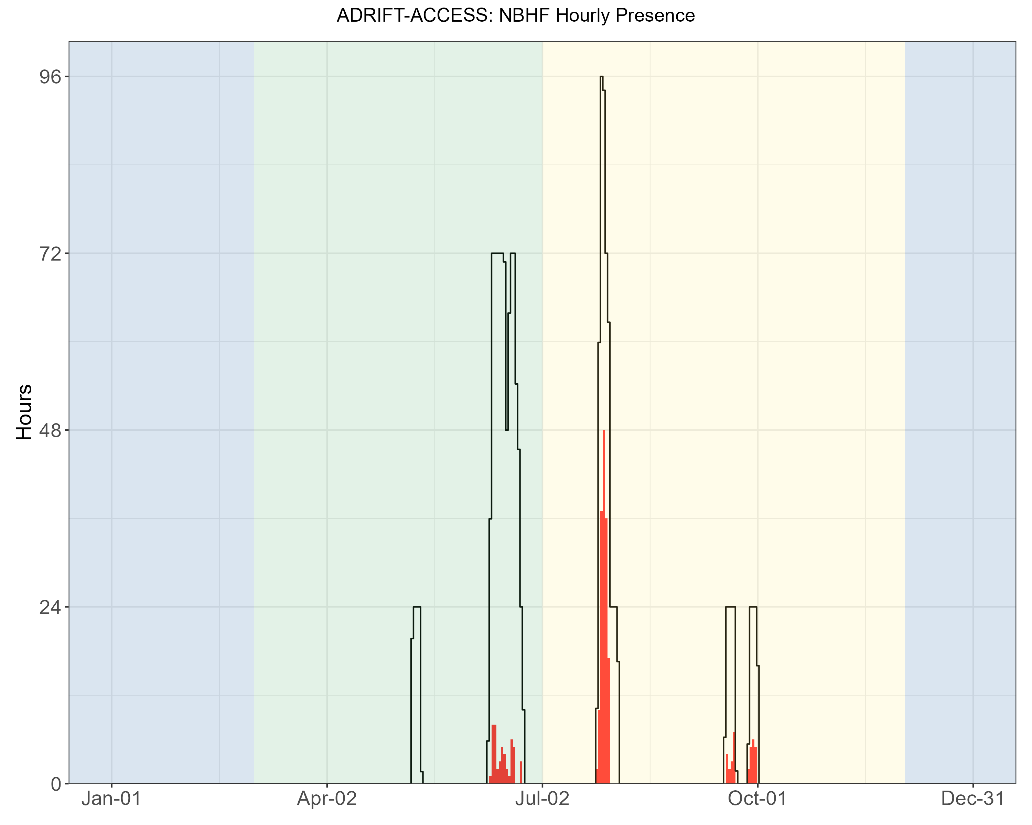

Figure . Hourly NBHF events by month for the Adrift-ACCESS surveys. Hourly presence of NBHF events (y axis) for different months for different months for combined years (x axis) during the Adrift-ACCESS surveys. Hourly presence for duty-cycled data relates to the portion of the hour included in the duty cycled data. Black lines represent total available hours (effort) and red lines represent hours with detections. Blue shading represents winter, green represents upwelling, and yellow represents the post-upwelling oceanographic season.

The California Current is home to 4 different species that produce NBHF echolocation clicks: harbor porpoise, Dall’s porpoise, pygmy sperm whales, and dwarf sperm whales. Despite the similarities in their echolocation clicks, these species inhabit different habitats and have different behaviors and life histories. Harbor porpoise inhabit the nearshore waters north of Point Conception, and are very sensitive to noise and other anthropogenic impacts. Dall’s porpoise are fast moving and are often found in mixed species aggregations with dolphins. Both the pygmy and dwarf sperm whales are cryptic deep diving species. Lumping these very different species into one ‘acoustic’ group is problematic, and acoustic classification to species (or at least genus) is needed.

Preliminary efforts at developing a genus-level species classifier for NBHF species in the California Current have shown positive results, and future research will further develop this classifier (see online [NBHF Classification Summary](https://sael-swfsc.github.io/Adrift/content/nbhfClassification.html)). These classifiers will be further developed in 2025 and we hope to re-examine the Adrift-ACCESS NBHF species to refine the species identity in these data.

### Blue Whales

Blue whales were detected in all deployments except the initial upwelling deployment (Figure 8), with most detections during the post-upwelling season (Table 6).

Table . Summary of blue whale detections in hourly bins for Adrift-ACCESS data.

|  |  |  |  |
| --- | --- | --- | --- |
|  | **Upwelling** | **Post-Upwelling** | **Winter** |
| **A Calls** | 0.00 (960) | 0.31 (688) | – |
| **B Calls** | 0.02 (960) | 0.50 (688) | – |
| **D Calls** | 0.03 (960) | 0.06 (688) | – |

Note: Summary of blue whale detections for A, B, and D calls in hourly bins for Adrift-ACCESS data. Mean hourly probability of blue whale detection for that call type/season; total hourly bins are shown in parenthesis.

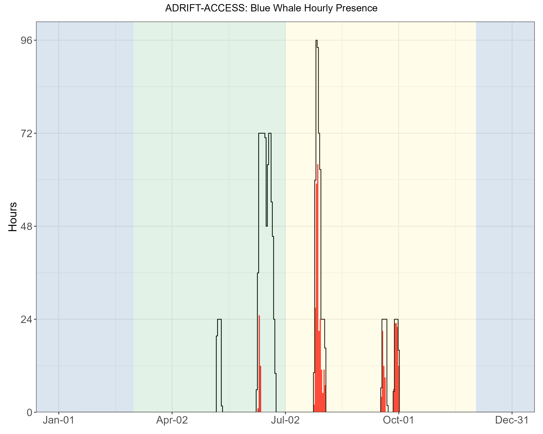

Figure . Hourly blue whale events by month for the Adrift-ACCESS surveys. Hourly presence of blue whale calls (A, B, and D types, combined) (y axis) for different months for combined years (x axis) during the Adrift-ACCESS surveys. Hourly presence for duty-cycled data relates to the portion of the hour included in the duty cycled data. Black lines represent total available hours (effort) and red lines represent hours with detections. Blue shading represents winter, green represents upwelling, and yellow represents the post-upwelling oceanographic season.

Detection of blue whale calls were primarily A and B calls associated with song, with few detections of D calls during the summer months (Figure 9). Blue whale ‘song’ consists of both A and B calls, which can occur individually or in A-B pairs. Detection of both A and B calls were higher during the post-upwelling seasons in all areas (Figure 8). There were only a few blue whale B calls detected during the upwelling season off San Francisco. The probability of detecting blue whale B calls was consistently higher than A calls, which reflects research showing that blue whale B calls can be detected at greater ranges than blue whale A calls (McDonald et al. 2001). Blue whale B calls can be readily classified by an experienced analyst when the SNR (signal to noise ratio) is low.

Blue whale D calls have been associated with feeding behavior (Oleson et al. 2007), and detection of D calls were primarily during the summer (late upwelling/early post-upwelling, Figure 9). The probability of detecting D calls was much lower than detecting A and/or B calls, and low SNR D calls are more readily confused with low frequency downsweep calls produced by other species, reducing the overall effective detection range for these calls.

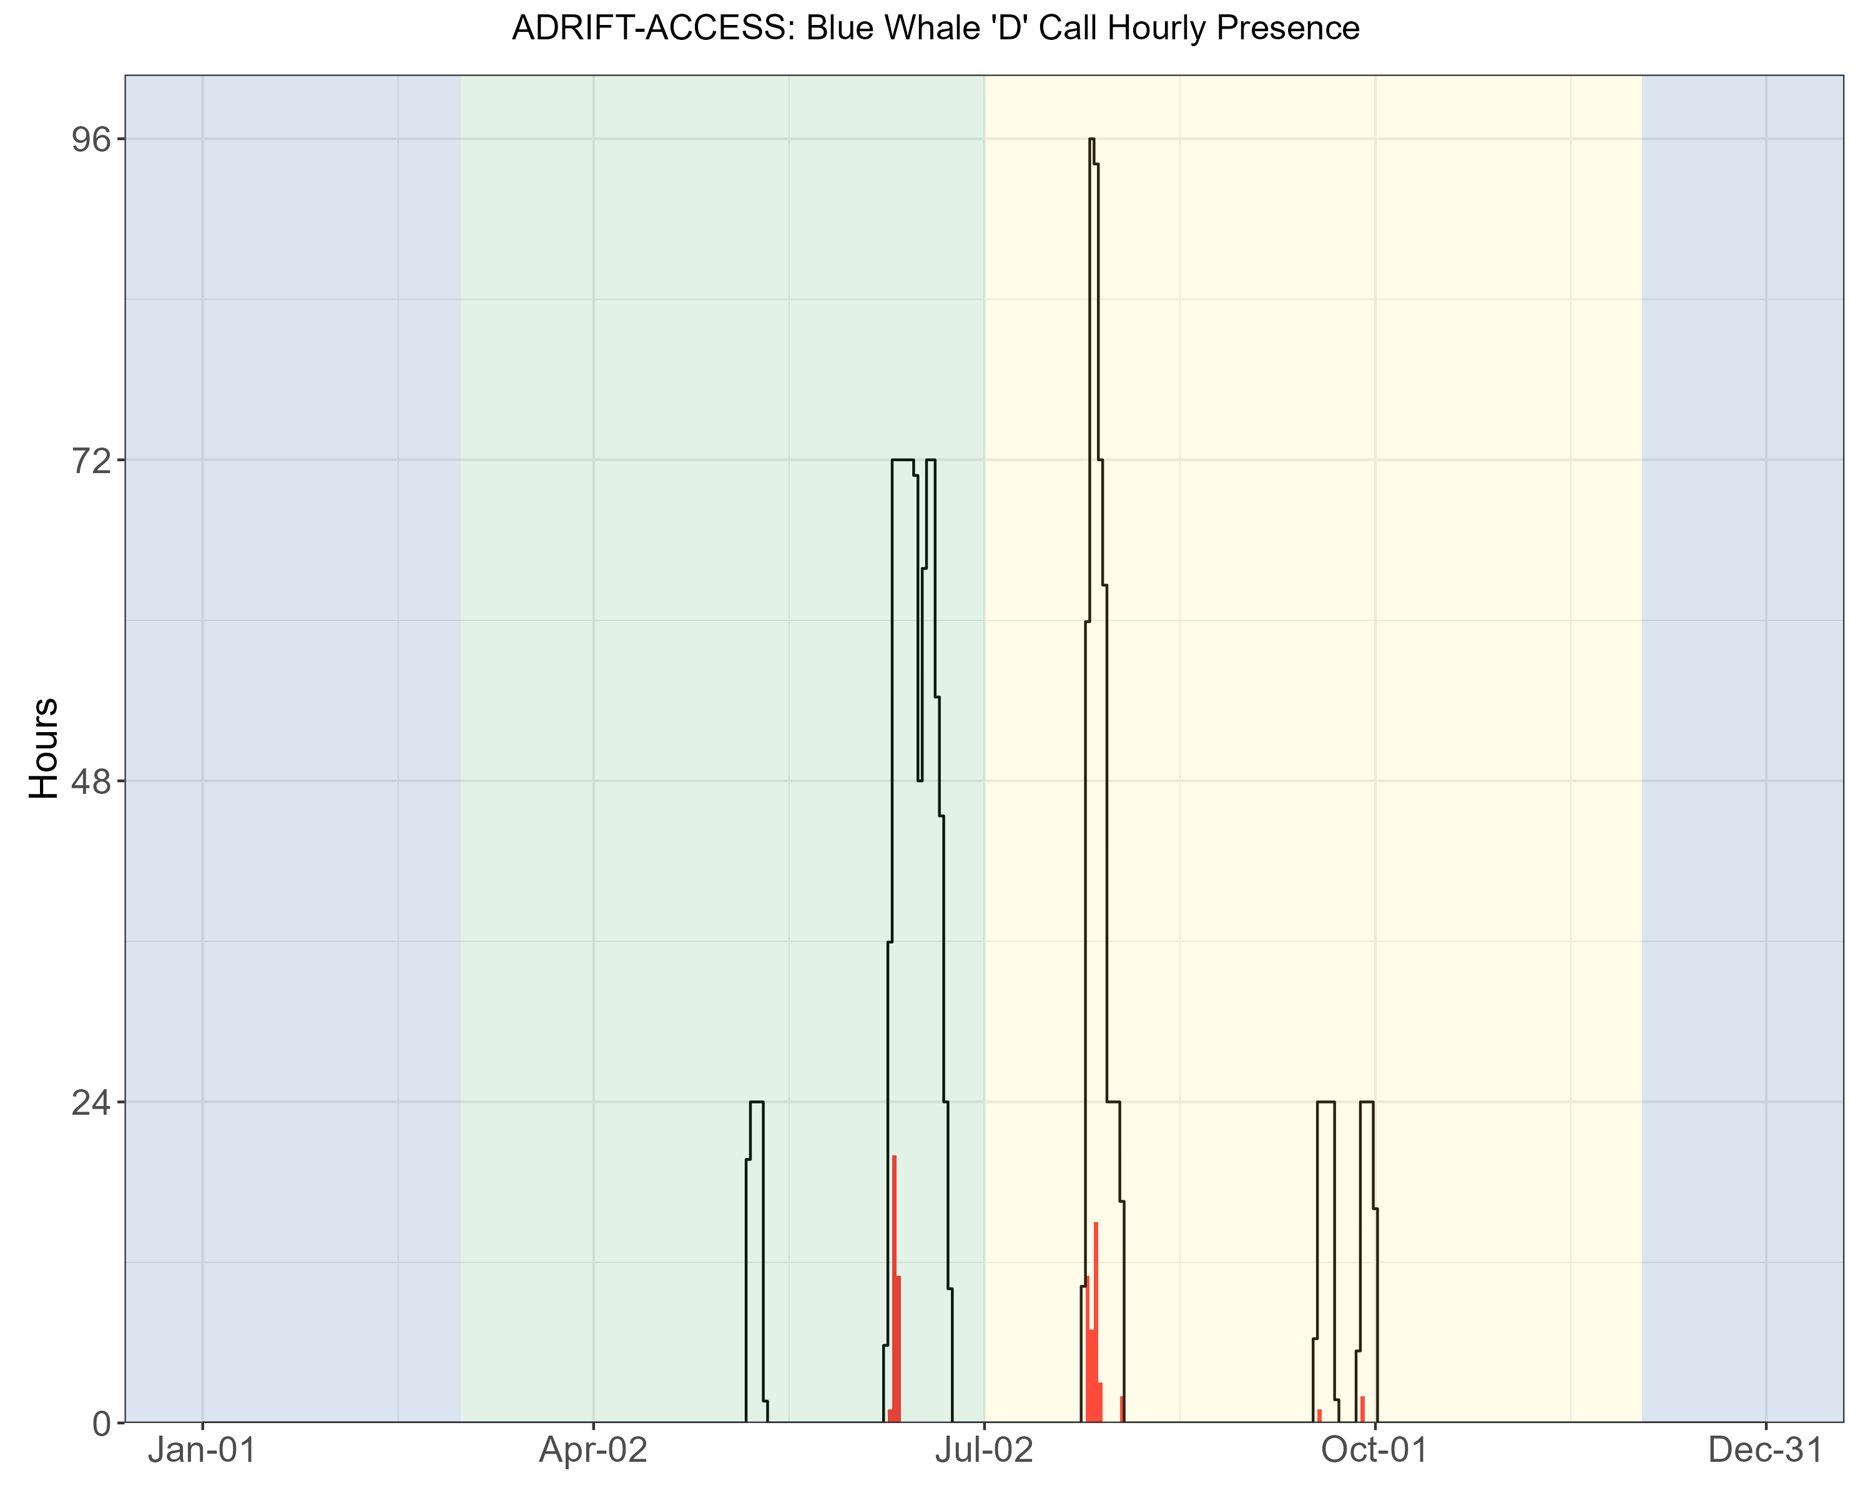

Figure . Hourly presence of blue whale D calls by month for the Adrift-ACCESS surveys. Hourly presence of blue whale D calls (y axis) for different months for combined years (x axis) during the Adrift-ACCESS surveys. Adrifts 001-012 were duty cycled and hourly presence relates to the portion of the hour included in the duty cycled data (6 min of 12 min). Black lines represent total available hours (effort) and red lines represent hours with detections. Blue shading represents winter, green represents upwelling, and yellow represents the post-upwelling oceanographic season.

Detection of blue whales was higher during the post-upwelling season, and detections were dominated by the A/B song call types produced by males. Foraging associated ‘D’ calls were primarily detected during the post-upwelling season, and at much lower detection probabilities than A/B call types. Blue whale calls, especially the ‘B’ call type, can be detected at great ranges and the range of potential sound source locations can be large. Preliminary methods to localize low frequency sounds on clustered drifting recorders shows promise (see online summary: [Modeling Habitat Use](https://sael-swfsc.github.io/Adrift/content/habitatModels.html)), and adoption of these methods may improve our understanding of the habitat use of these species in the greater area.

### 

### Fin Whales

Fin whales 20 Hz calls were detected during both the upwelling and post-upwelling seasons, with greater hourly detection during the post-upwelling deployments (Table 7). There were no detection of fin whale 40 Hz calls during the Adrift-ACCESS deployments (Table 7).

Table . Summary of fin whale detections in hourly bins for Adrift-ACCESS data.

|  |  |  |  |
| --- | --- | --- | --- |
|  | **Upwelling** | **Post-Upwelling** | **Winter** |
| **20 Hz** | 0.04 (960) | 0.12 (688) | – |
| **40 Hz** | 0.00 (960) | 0.00 (688) | – |

Note: Summary of fin whale 20 Hz and 40 Hz detections in hourly bins for Adrift-ACCESS data. Mean hourly probability of fin whale detection for that call type/season; total hourly bins are shown in parenthesis.

Fin whale 20 Hz detections were lower off San Francisco than other areas (see [online Adrift results](https://sael-swfsc.github.io/Adrift/content/fin.html)), though detection of low frequency fin whale calls in this area may be compromised by low frequency noise associated with high levels of low frequency noise associated with large shipping traffic (container ships). The fin whale 20 Hz call is the most commonly reported and is thought to be used as a social call to establish and maintain contact when produced in irregular sequences (Edds-Walton 1997) and it may serve a reproductive function when produced by males in a regular sequence forming song (Croll et al. 2002). Here we did not differentiate between irregular and regular sequencing.

The 40 Hz call has a more irregular pattern and has been positively associated with prey biomass, providing evidence that it is associated with a foraging function (Romagosa et al. 2021). There were no detections of fin whale 40 Hz calls in this region (Table 7).

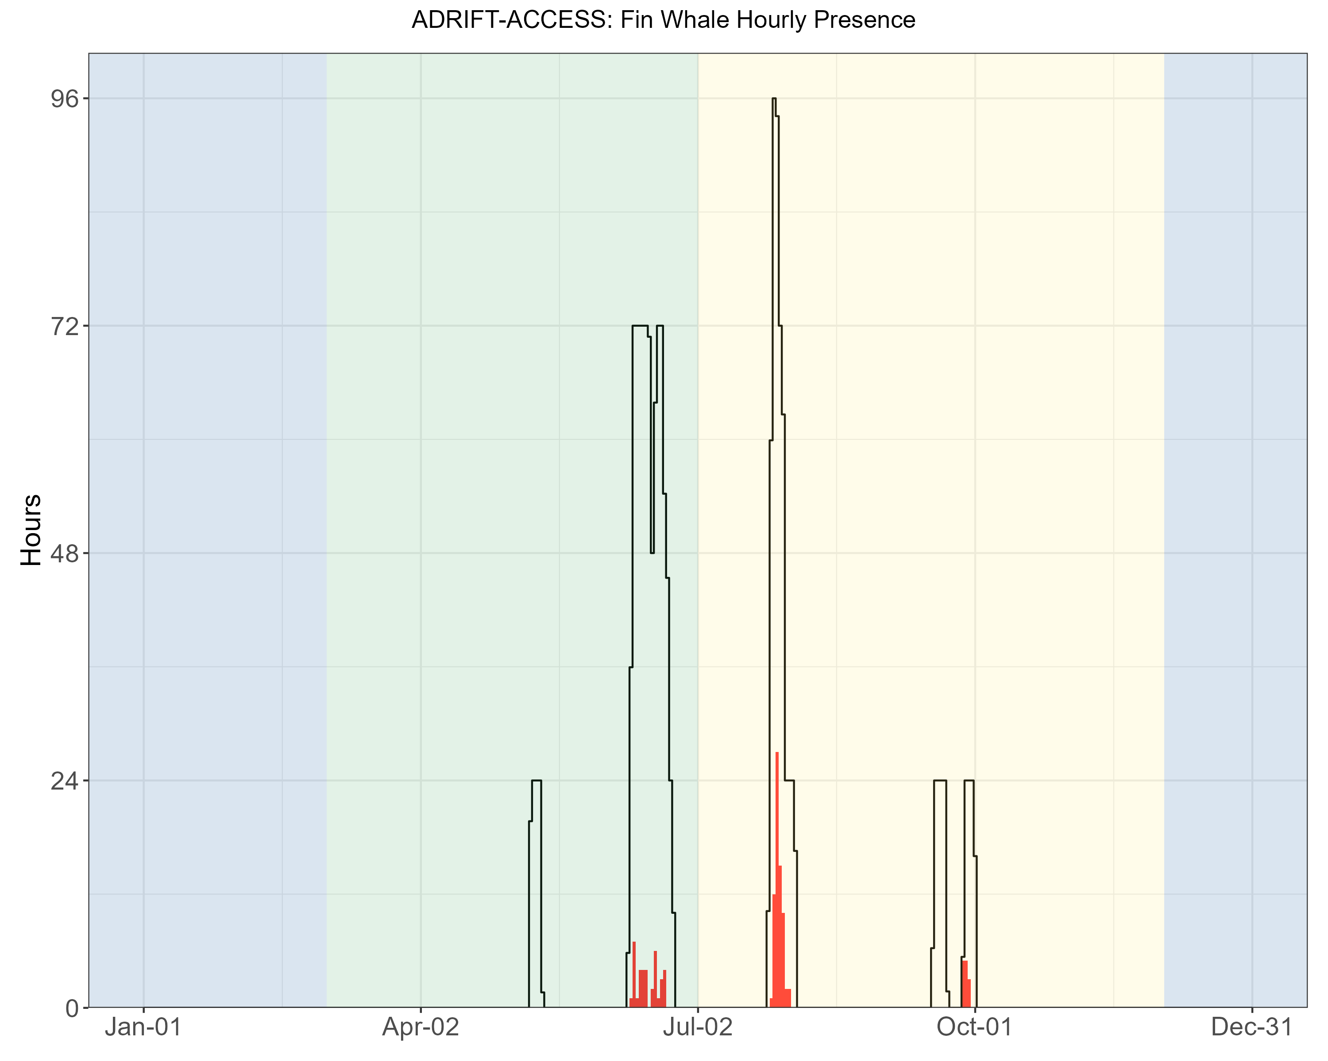

Figure . Hourly fin whale events by month for the Adrift-ACCESS surveys. Hourly presence of fin whales (combined call types) (y axis) for different months for combined years (x axis) during the Adrift-ACCESS surveys. Hourly presence for duty-cycled data relates to the portion of the hour included in the duty cycled data. Black lines represent total available hours (effort) and red lines represent hours with detections. Blue shading represents winter, green represents upwelling, and yellow represents the post-upwelling oceanographic season.

These data were used to improve and test a fin whale classifier with excellent results (see online summary: [Fin Whale AI](https://sael-swfsc.github.io/Adrift/content/finAI.html)), and future adoption of these methods may allow for an improved approach of classifying variability in fin whale call patterns.

### Humpback Whales

Humpback whales were detected during most deployments (Figure 11), with higher probability of detection in the post-upwelling season off San Francisco (Table 8). Hourly probability of detecting song was higher in the post-upwelling than the upwelling season (Table 8).

Table . Summary of humpback whale detections in hourly bins for Adrift-ACCESS data.

|  |  |  |  |
| --- | --- | --- | --- |
|  | **Upwelling** | **Post-Upwelling** | **Winter** |
| **Song** | 0.03 (960) | 0.36 (688) | – |
| **Social Calls** | 0.01 (960) | 0.24 (688) | – |
| **Undetermined Humpback Calls** | 0.06 (960) | 0.28 (688) | – |

Note: Summary of humpback whale detections for Song, Social sounds, and Unidentified calls in hourly bins for Adrift-ACCESS data. Mean hourly probability of humpback whale detection for that call type/region/season; total hourly bins are shown in parenthesis.

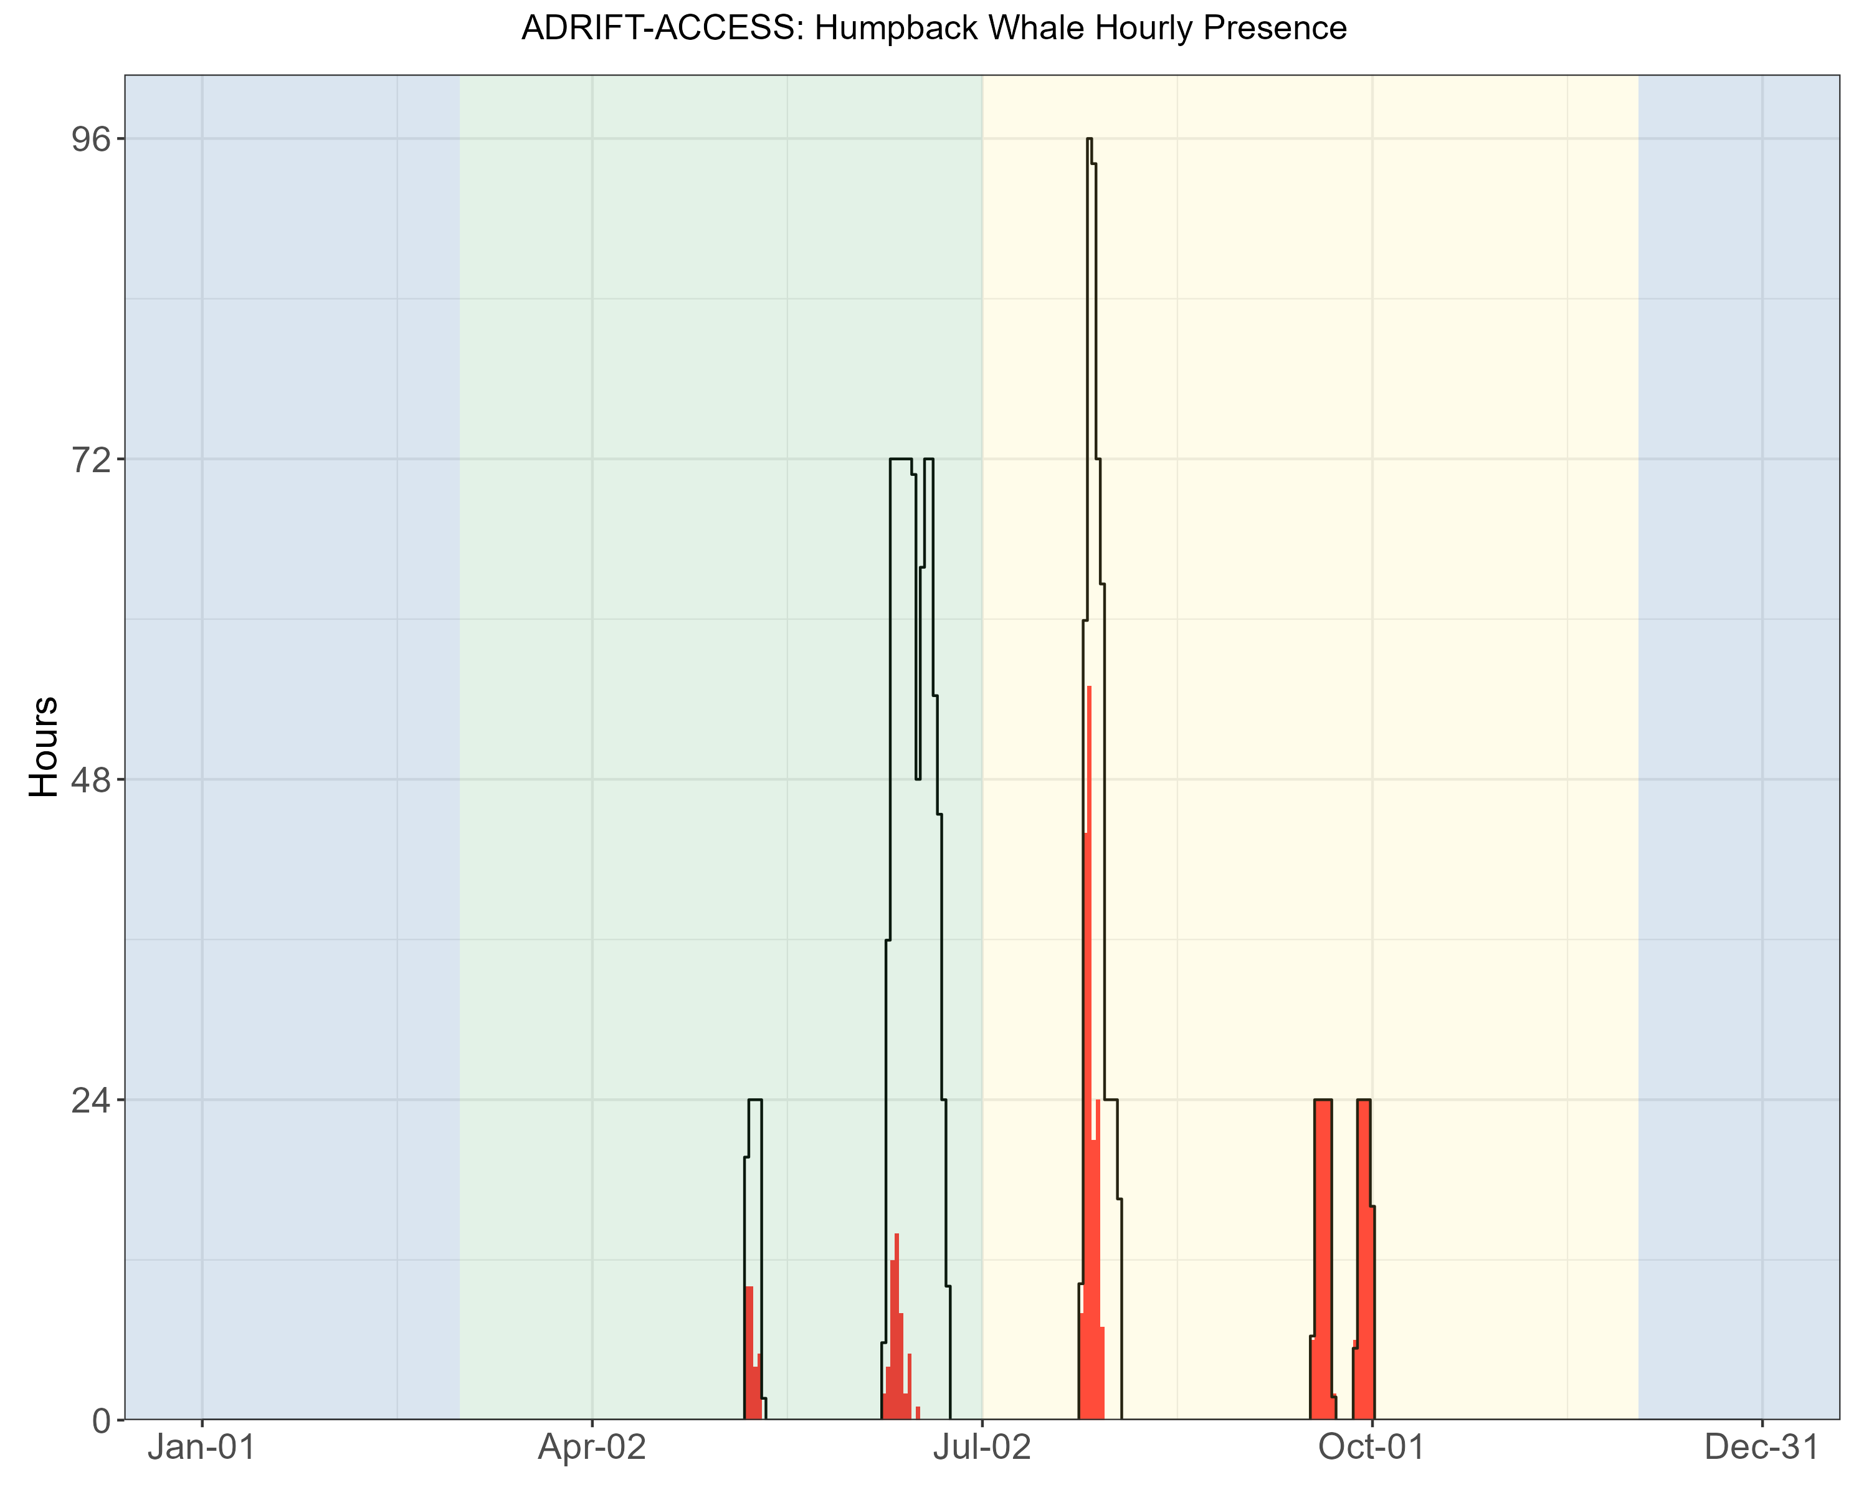

Figure . Hourly humpback whale events by month for the Adrift-ACCESS surveys. Hourly presence of combined humpback whales call types (y axis) for different months for combined years (x axis) during the Adrift-ACCESS surveys. Hourly presence for duty-cycled data relates to the portion of the hour included in the duty cycled data. Black lines represent total available hours (effort) and red lines represent hours with detections. Blue shading represents winter, green represents upwelling, and yellow represents the post-upwelling oceanographic season.

There were no deployments during the winter oceanographic season, but high probability of detecting humpback song during the late fall aligns with the production of song during the southern winter migration (Clapham and Mattila 1990). There were several drifts in which humpback song dominated the recordings (Figure 12). The acoustic features of humpback whale song, including high source level and series of calls produced over long time spans, naturally lead to high detection rates (Au et al. 2006). While recordings dominated by song may be attributed to one or a few animals, social sounds may be attributed to larger numbers of animals (Ryan et al. 2019).

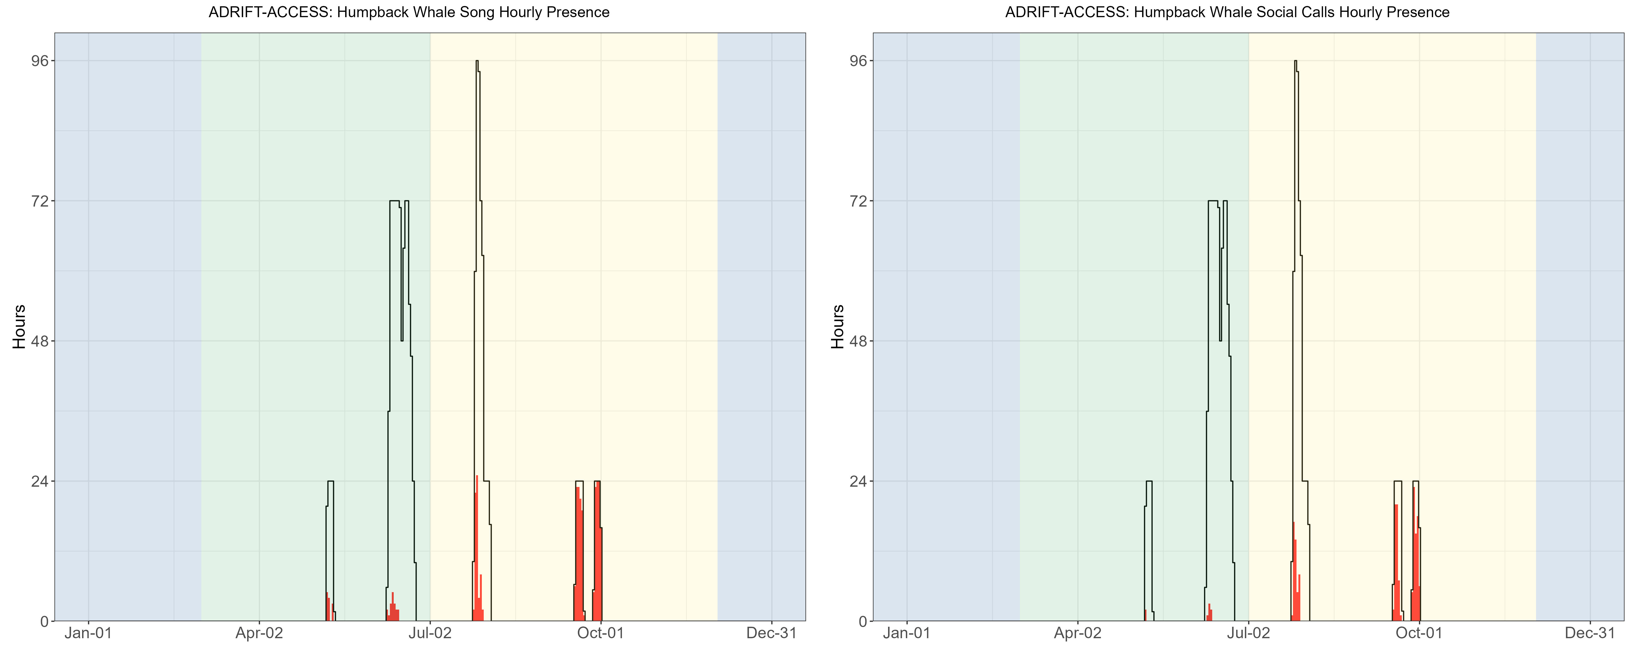

Figure . Hourly presence of humpback song, social calls by month for the Adrift-ACCESS surveys. Hourly presence of humpback song (left) and humpback social calls (right)(y axis) for different months for combined years (x axis) during the Adrift-ACCESS surveys. Adrifts 001-012 were duty cycled and hourly presence relates to the portion of the hour included in the duty cycled data (6 min of 12 min). Black lines represent total available hours (effort) and red lines represent hours with detections. Blue shading represents winter, green represents upwelling, and yellow represents the post-upwelling oceanographic season.

Humpback whales are notoriously difficult PAM subjects due to their very active vocal behavior (in quantity and variability). Many recordings can be dominated by humpback song, and this song may be the result of a single individual. There is significant research on many of the non-song vocalizations, but detection and classification of these sounds require expertise and manual classification. There are significant numbers of annotated datasets, and development of a machine learning method to detect and classify these sounds would allow researchers to better understand how the detection of humpback sounds can inform the demographic composition and habitat use of these species throughout the California Current.

### Bryde’s and Sei Whales

There were no confirmed detections of calls associated with Bryde's or sei whales during Adrift-ACCESS. Bryde’s whale distribution is in the tropical and subtropical waters, with occasional northward incursion into the Southern California Bight (Kerosky et al. 2012). The Adrift-ACCESS deployments were north of their expected range; however, warming oceans associated with climate change may lead to an increase in detections in northern latitudes over time.

There were no known acoustic detections of sei whales during the Adrift-ACCESS deployments. Little is known about sei whales in the North Pacific, and to our knowledge there is only one confirmed recording of sei whales in the North Pacific, near Hawaii (Rankin and Barlow 2007).

### Gray Whales

Sounds associated with gray whales were only detected on a few recordings during the post-upwelling Adrift-ACCESS deployments (Table 9). There is a significant overlap in spectral content for humpback and gray whale calls and care should be taken when inferring gray whale presence from data with concurrent humpback whale presence.

Table . Summary of gray whale detections in hourly bins for Adrift-ACCESS data.

|  |  |  |  |
| --- | --- | --- | --- |
|  | **Upwelling** | **Post-Upwelling** | **Winter** |
| San Francisco | 0.00 (960) | 0.07 (688) | – |

Note: Summary of gray whale detections for Adrift-ACCESS data. Mean hourly probability of gray whale detection for that region/season; total hourly bins are shown in parenthesis.

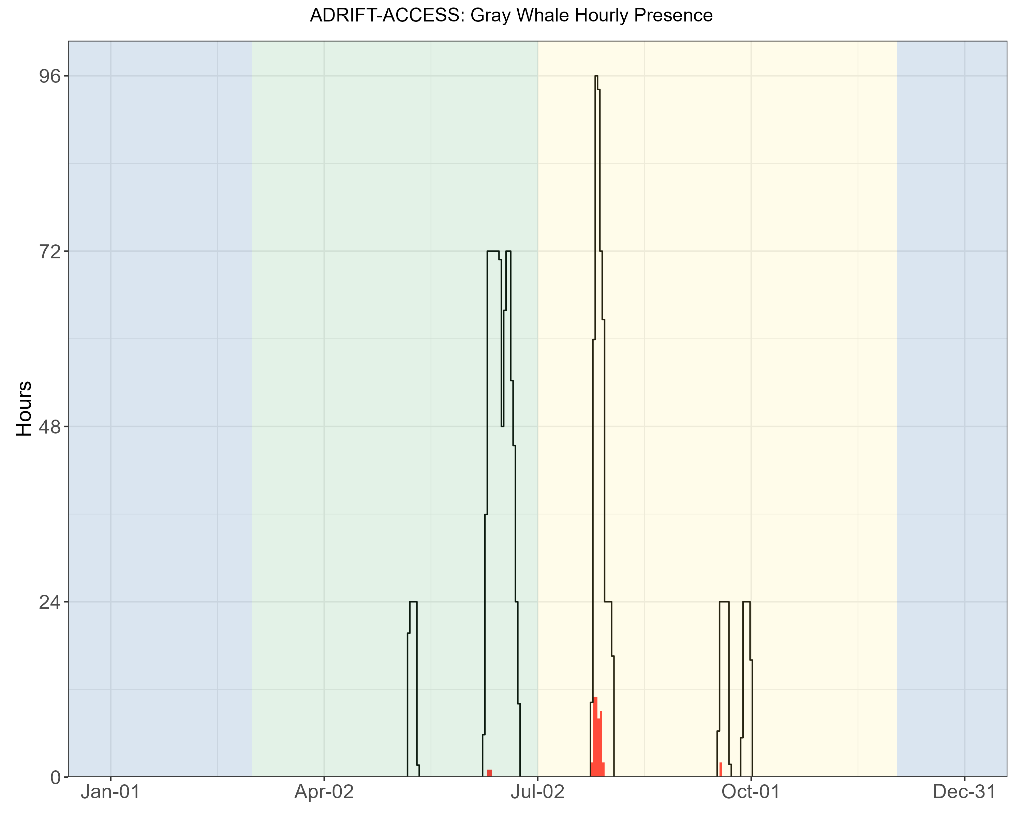

Figure . Hourly gray whale events by month for the Adrift-ACCESS surveys. Hourly presence of gray whale calls (y axis) for different months for combined years (x axis) during the Adrift-ACCESS surveys. Hourly presence for duty-cycled data relates to the portion of the hour included in the duty cycled data. Black lines represent total available hours (effort) and red lines represent hours with detections. Blue shading represents winter, green represents upwelling, and yellow represents the post-upwelling oceanographic season.

Most Eastern North Pacific gray whales use the California Current to migrate between their feeding grounds in the north and their winter breeding grounds in Baja California. A subpopulation of these whales known as the ‘Pacific Coast Feeding Group’ feed in the California Current off Northern California, Oregon, and Washington during the upwelling and post-upwelling seasons (Barlow et al. 2024). Gray whales are typically found in the nearshore waters, but do occur in [offshore waters](https://seamap.env.duke.edu/dataset/861).

### Minke Whales

There were no detections of minke whale boings during the Adrift-ACCESS. Minke whale boing calls are considered 'song' and typically detected during the winter and early spring months where our study has limited effort (Rankin and Barlow 2005). The lack of detections could be due to low population densities or that minkes use coastal waters. Research is needed to improve our knowledge of the minke whale vocal repertoire.

## Soundscape

The purpose of soundscape monitoring was to describe the ambient noise level(s) and to identify the major contributors to the soundscape. To that end, we measured soundscape metrics and identified two primary sources of noise: self-noise and ship noise. Weather (wind, rain) is a significant contributor to soundscape and varies by season/region. Although we did not quantify this in our analysis, we recommend that future research include weather as a contributor to the soundscape. These data were combined with the detection of biological sounds from marine mammals to examine the biological and anthropogenic contributors to the soundscape.

The SanctSound methods were initially adopted to provide data consistent with previously analyzed data. Soundscape methods have changed significantly in the last three years, and the most recent recommendation is to report sound levels in hybrid millidecade bands. While there is now open-source software that can produce these metrics, it was not available for our analysis. All of our data is publicly available and the LTSAs were retained so that the data can be converted in the future. We recommend that data be reanalyzed to report sound levels in hybrid millidecade bands to align with current standards.

### Power Spectral Density

The Power Spectral Density (PSD) is the measure of the signal's power as a function of frequency, and the PSD plots provide a visualization of the ambient noise for each region and season (Figure 14). Contributing sounds include biological sounds (marine mammals, fish, invertebrates), environmental noise (wind, rain), and anthropogenic noise (vessel noise, depth sounders, seal bombs). While Figure 14 includes all contributors to the soundscape, seasonal and regional differences can be informative and provide valuable pre-development information regarding the general soundscape. In general, noise levels ranged from 50 dB re 1uPa to nearly 150 dB re 1uPa, with the highest density of sound in the 75 - 100 dB range (Figure 14).

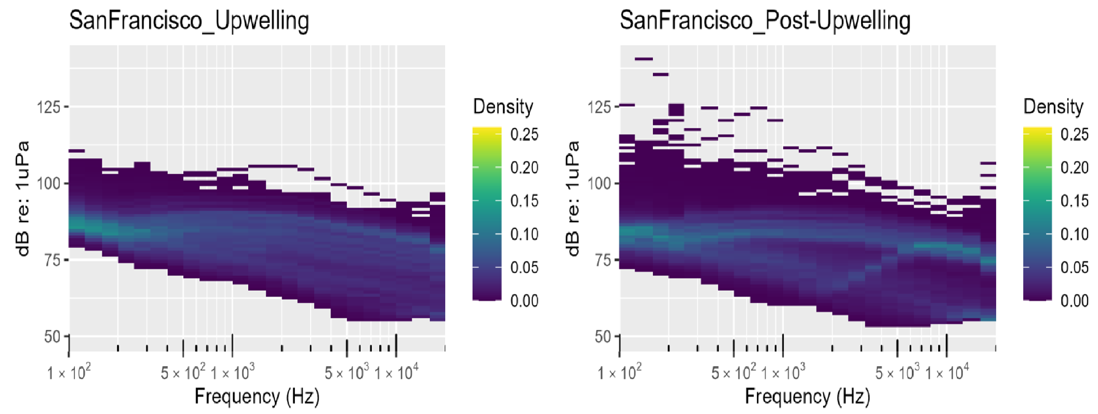

Figure . Power spectral density for Adrift-ACCESS deployments by season.

Other researchers have developed models to separate the distinct contributions of ship and wind noise to soundscapes (Erbe et al. 2021; ZoBell et al. 2024). These models have been validated with empirical data and can be in close agreement in certain times and places, but validation has been very limited to small spatiotemporal scales. The data collected in offshore waters of the Adrift-ACCESS survey can be used to validate models which separate wind and shipping contributions to sound levels. This will be an important next step for evaluating changes in the soundscape associated with offshore wind development areas.

Low frequency noise associated with strumming precluded consistent analysis of soundscape below 100Hz. Future drifting recorder studies should consider alternative configurations that eliminate strumming and other self-noise to allow for broadband soundscape analysis.

### Ship Noise

Ships produce different sounds while operating, such as impulsive signals from ship propeller cavitation or echosounder signals that can be easily identified in the LTSA and confirmed with a spectrogram. During the upwelling season, vessel noise was largely consistent throughout the day (with a slight decrease during the night); however, vessel noise was much higher in the late morning in the post-upwelling season (Figure 15).

Hourly presence of ships in San Francisco appears to be lower than other regions (Figure 15). Our analysis of ship noise considers detection of noise from specific vessels rather than the presence of background ship noise. Analysts noted an overall high level of ambient noise associated with background ship noise (Figure 14) and a reduced ability to detect individual vessels. Detection of vessels used manual detection methods (existing automated vessel detectors were not reliable for this dataset); development of a standardized vessel detector that works across datasets could be used to determine if individual ship tracks are difficult to detect in high traffic areas. Future work can include an Automatic Identification System metric such as the number of unique large vessels with relatively close approaches.

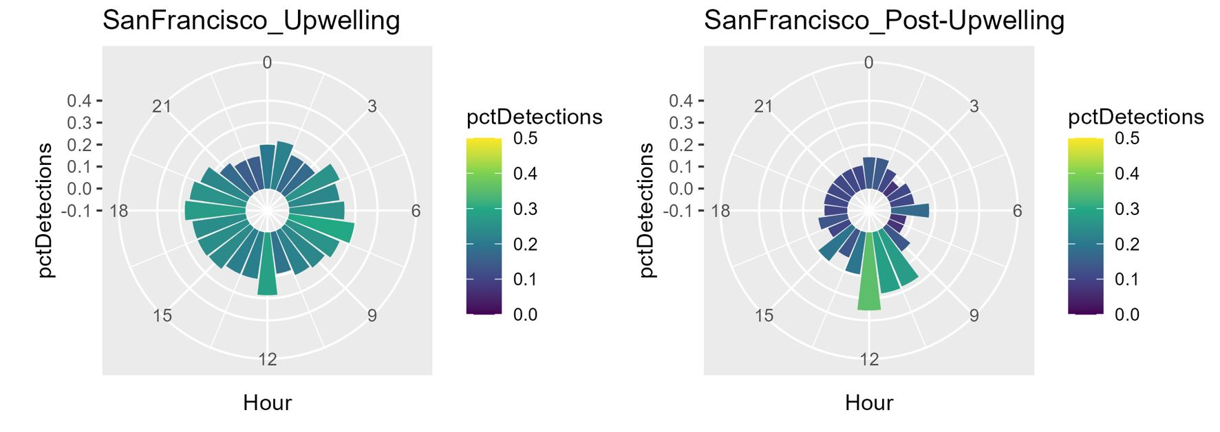

Figure . Polar plots of seasonal detection of ship noise in the Adrift-ACCESS surveys. The hourly percent of effort with vessel detections is shown in color ranging from dark blue (0%) to yellow (50%). The diurnal variation in vessel noise is shown by detection in bins on polar plot ranging from 0 to 24 hr of the day (UTC, Universal Time Coordinated).

### Contributors to the Soundscape

The marine soundscape includes sounds associated with physical drivers (rain, waves, earthquakes), biological sources (sounds produced by marine mammals, fish, and invertebrates), as well as anthropogenic sounds. In this study we examined sounds attributed to a number of marine mammal species as well as ship noise. Temporal variation (marked in hourly bins) in the contribution of these sounds to the overall soundscape are provided by the acoustic scene. An acoustic scene provides a visualization of the spectral variation in the contributors to the soundscape, where detection of various species classes is noted by the approximate frequency of their sounds.

Deployments offshore San Francisco were coordinated with NOAA Sanctuaries' ACCESS Surveys during the upwelling and post-upwelling oceanographic seasons (Figure 16, Figure 17, Figure 18). Visualizations represent data from 1 or 2 buoys at greater distance from each other (other Adrift buoys were deployed in clusters). Differences in geographic location of deployments in the upwelling and post-upwelling seasons may complicate interpretation of seasonal differences in marine mammal detections (see Figure 2).

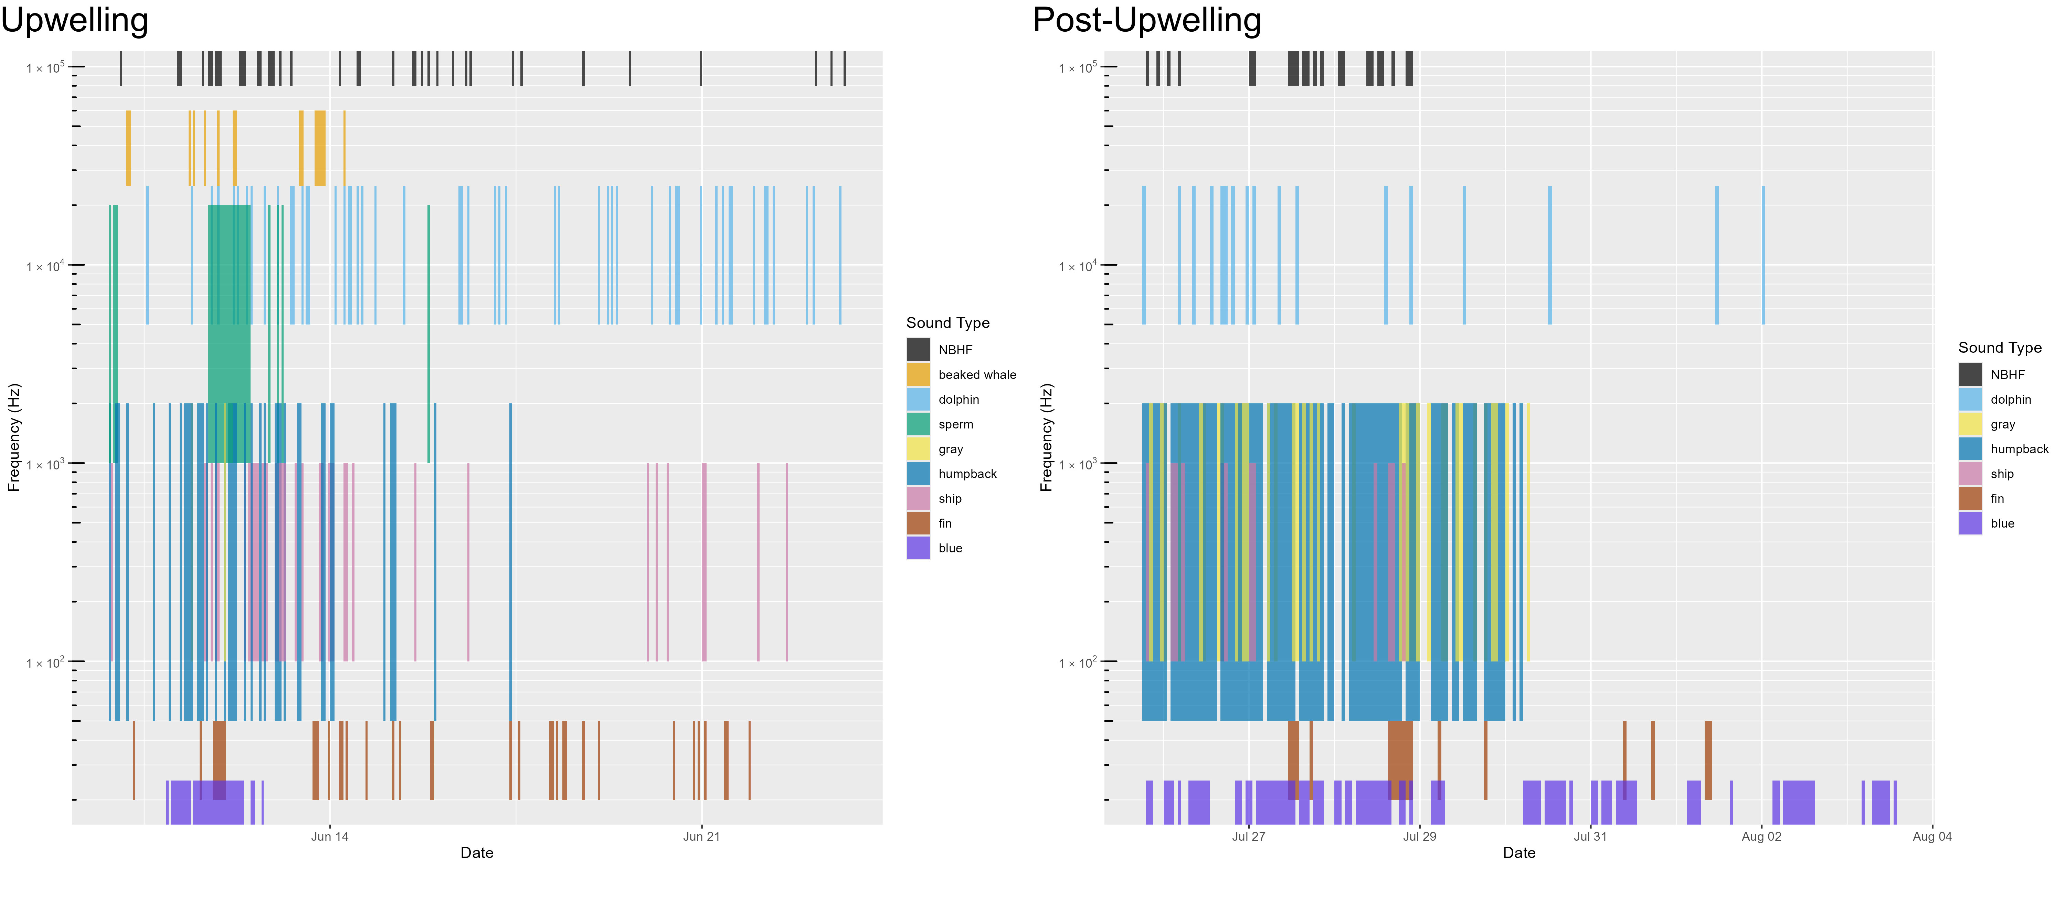

Figure . Acoustic scene for San Francisco, 2021. Acoustic scene showing detections of various contributors to the soundscape for the 2021 San Francisco deployments in the upwelling and post-upwelling oceanographic seasons.

Detection of odontocetes (including NBHF, beaked whales, sperm whales, and dolphins) varied by drift (Figure 16, Figure 17, Figure 18). Detection of baleen whales (humpback, gray, fin, and blue whales) varied by drift, with a general increase in detections of many baleen whale species during the post-upwelling season.

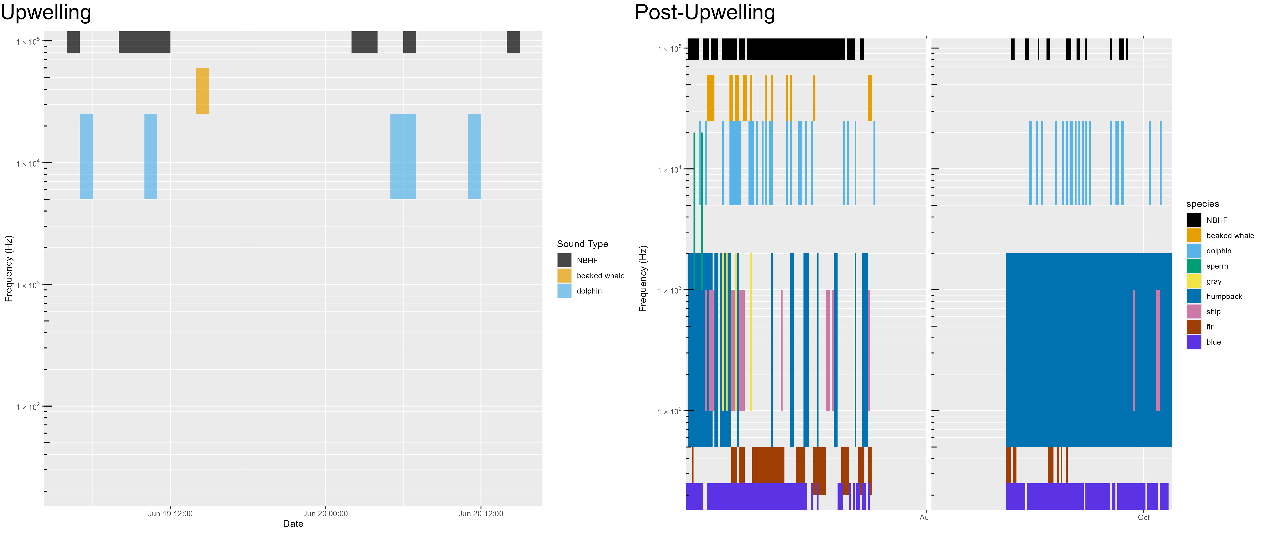

Figure . Acoustic scene for San Francisco, 2022. Acoustic scene showing detections of various contributors to the soundscape for the 2022 San Francisco deployments in the upwelling and post-upwelling oceanographic seasons.

Despite the drift locations being near a convergence of shipping lanes entering San Francisco Bay, detection of specific vessels was relatively modest. Higher ambient noise in this region may have led to decreased detection of individual vessel tracks due to masking.

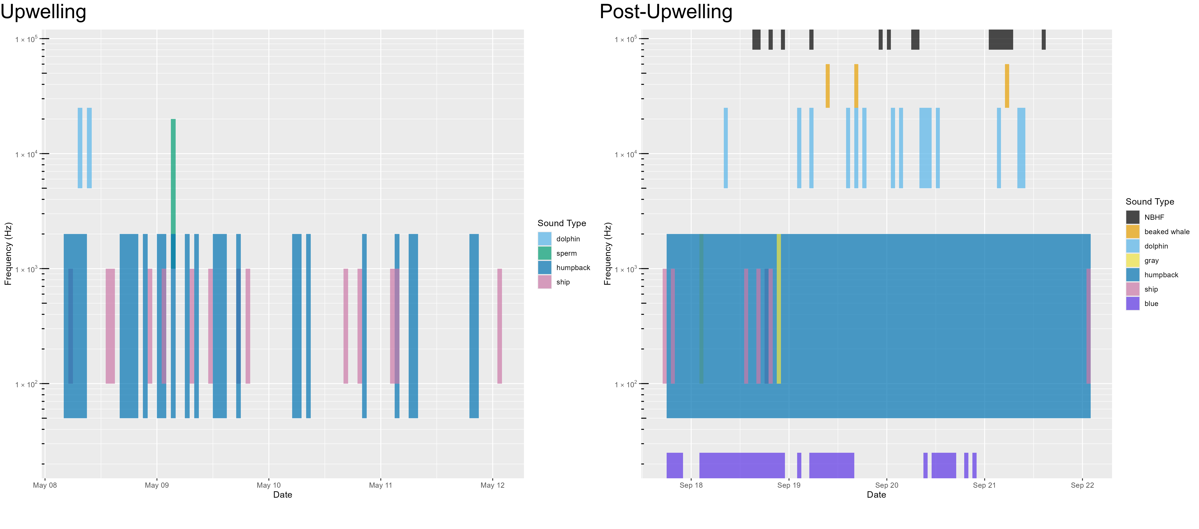

Figure . Acoustic scene for San Francisco, 2023. Acoustic scene showing detections of various contributors to the soundscape for the 2023 San Francisco deployments in the upwelling and post-upwelling oceanographic seasons.

The marine soundscape includes sounds associated with physical drivers (rain, waves, earthquakes), biological sources (sounds produced by marine mammals, fish, and invertebrates), as well as anthropogenic sounds. During the course of this study we developed automated methods to integrate physical drivers (environmental variables), biological sources (marine mammal detections), as well as anthropogenic sounds to better understand these various contributors to the soundscape, and how they change over time. While we had limited time to conduct advanced analyses, our research efforts took a significant step forward so that future researchers can more readily integrate these methods into their analyses (see online summary of open source software developed as part of this project: [Adrift Software](https://sael-swfsc.github.io/Adrift/content/software.html)).

# Data Sharing

NOAA is committed to increasing the accessibility of publications and digital data produced by federal researchers through the Public Access to Research Results. Publications (including reports) can be accessed at the NOAA Institutional Repository. Links to raw data, data products, detailed methods and the Adrift research compendium are provided in the online summary for [Data Sharing](https://sael-swfsc.github.io/Adrift/content/dataSharing.html).

In addition to public sharing of our research results, the Southwest Acoustic Ecology Lab firmly believes that analysis methods should be publicly accessible. Most methods were developed in open-source software and publishing analytical methods as R packages, available on [CRAN](https://cran.r-project.org) (Comprehensive R Archive Network). More information on our open-source analysis packages can be found on our [online summary for Adrift Software](https://sael-swfsc.github.io/Adrift/content/software.html).

In addition to public access to raw data, we have also shared a sample of audio files for public use via [Soundcloud web platform](https://soundcloud.com/southwestacousticecology).

# Education and Outreach

The study of ocean sound is interdisciplinary and provides a natural opportunity for community engagement in formal education (K-12), informal science learning (museums), and online crowd-source citizen science participation. Our team engaged with students, journalists, and educators to develop materials and tools to make our science accessible to the public. Education and Outreach efforts included mentoring students and interns on authentic research projects, inviting journalists to participate in fieldwork, collaborating with educators to develop lesson plans for many age groups, and developing a preliminary crowd-sourced Zooniverse platform for community involvement in our research. We encourage sharing these resources broadly.

In 2020 we collaborated with San Diego Unified School District (SDUSD) to host a teachers' workshop to develop a series of phenomena-based instructional curricula. Lessons aligned with Next Generation Science Standards and included instructional units for elementary schools ([Dolphins have Needs](https://drive.google.com/file/d/1VE2-jXCJet4iO_4bWywwW0dPtOK1BcLA/view)), Middle School ([You can recognize different species by the sounds they make](https://drive.google.com/file/d/1MsorXXkcHk8YNyHgldJ_-ApASLcEkoJy/view)) and High School ([Ocean noise impacts marine mammals](https://drive.google.com/file/d/17qMPka0tTKjmF8jlAQD24QiWRzs3E9P4/view)). Lessons plans are publicly available on the [Project Phenomena Database](https://www.sdcoe.net/ngss/phenomena-and-the-ngss) website.

Data Nuggets are free classroom activities designed to bring contemporary research and authentic data into the classroom. Data Nuggets were recommended by our teacher collaborators during the SDUSD workshop as a highly useful format for Science Technology Engineering Mathematics in the classroom. We collaborated with Data Nuggets to create ‘[Eavesdropping on the Ocean](https://datanuggets.org/2024/04/eavesdropping-on-the-ocean)’. This Data Nugget provides background on the research question, authentic data to allow classrooms to work with real data to apply to the research question, as well as links for additional information. This has been made publicly available for teachers at no cost.

In addition, we initiated a Zooniverse Project, [Ocean Voices](https://www.zooniverse.org/projects/annelistens/ocean-voices). The initial intention of this effort was to use citizen scientists to label datasets as either humpback whales or ship noise; these annotations would then be used to develop an improved machine learning classifier. This required significant effort to automate development of paired spectrograms and acoustic recordings for the platform. The citizen scientist portion of this project will be delayed until future continuation of the work done during the Adrift study, however, the platform can currently function as an education learning tool. The software tools designed to manipulate acoustic data for input to Zooniverse are available on [GitHub](https://github.com/TaikiSan21/wav2mp3).

Our periodic 'Sound Bytes' blog provides a general audience with insight into the day-to-day work behind the science. Topics range from '[Lessons learned from Fishermen](https://www.fisheries.noaa.gov/science-blog/sound-bytes-fresh-catch-lessons-fisherman)’ to how we ‘[What we can learn from how Indigenous people listen](https://www.fisheries.noaa.gov/science-blog/sound-bytes-what-we-can-learn-how-indigenous-peoples-listen)’ to how we ‘[Hook young scientists on Research](https://www.fisheries.noaa.gov/science-blog/sound-bytes-hooking-young-students-research)’. We have had a host of guest bloggers, including students, interns, and collaborators. These blogs are shared on [NOAA's website](https://www.fisheries.noaa.gov/taxonomy/term/1000356091) and they have been promoted through numerous NOAA newsletters. Cory Hom-Weaver led these efforts and was recognized for an Award by NOAA's Southwest Fisheries Science Center for the excellent education and outreach provided by the Sound Bytes blog.

Additional media and student projects include:

* Will San Francisco’s wind farms damage underwater life? Here’s what scientists are finding. [San Francisco Chronicle](https://www.sfchronicle.com/climate/article/california-wind-farm-17277935.php#photo-22656909), July 7 2022.
* How could offshore wind impact marine life off SLO County coast? Experts listen for answers. [San Luis Obispo Tribune](https://www.sanluisobispo.com/news/local/environment/article273259360.html). March 20, 2023.
* Pacific white-sided and Risso's dolphin acoustic monitoring in a warming California Current ([youtube)](https://www.youtube.com/watch?v=eGEglgvAQY8). Alexandra Fiske, Seatech intern, Oakland Technical High School, 2021-2022
* Diurnal and Nocturnal Delphinid Echolocation Click Patterns off the California Coast in 2018 ([youtube](https://youtu.be/qkdHeOOh0VY?t=2070)). Keisha Askoak, Seatech intern, Mt. Edgecumbe High School, 2022-23
* Occurrence of Anthropogenic Noise and Humpback Whales in California in 2018 ([youtube](https://www.youtube.com/watch?v=qkdHeOOh0VY&t=1078s)). Audrey Bahnke, Sarah Bahnke, Virginia Pearson, Seatech interns, Mt. Edgecumbe High School, 2022-23.
* Spatial patterns in humpback whale song in central California waters ([youtube](https://youtu.be/XU-3Fo1XcBw?feature=shared)). Virginia Pearson, Seatech intern, Mt. Edgecumbe High School, 2023-24
* Spatial and temporal patterns of Bocaccio rockfish chorusing in central California ([youtube](https://youtu.be/XU-3Fo1XcBw?feature=shared)). Gale McCrary, Rie Christensen, Seatech interns, Mt. Edgecumbe High School, 2023-24.
* Using passive acoustic data to assess sperm whale population structure in the California Current. NOAA EPP Scholar Brittany Melton.
* 2021 NOAA EPP Projects: Humpback Whale Acoustics. NOAA EPP Scholar Maya Philipp.
* Assessing noise exposure to beaked and sperm whales in the California Current. Marina Bozinovic, Master of Science thesis, SFSU.
* Classifying species producing narrowband high-frequency echolocation clicks in the California Current. Jackson Vanfleet-Brown, Master of Science thesis, SFSU

# Conclusions and Future Directions

The greater Adrift in the California Current survey was intended to provide additional baseline data on marine mammals and the marine soundscape to inform management of offshore renewable resource development in the California Current. The Adrift-ACCESS collaboration between NOAA Fisheries and the Greater Farallones and Cordell Bank National Marine Sanctuaries provided an opportunity to deploy drifting recorders in and near the sanctuary waters offshore San Francisco Bay. Specific objectives of the Adrift-ACCESS Survey included assessing the viability and value of deploying drifting recorders during ACCESS Surveys, identifying marine mammal species within the sanctuaries, and providing additional information on the detection of blue and fin whales within and offshore the sanctuaries.

***Determine the viability and value of coordinated drifting recorder PAM monitoring during ACCESS Surveys***

Drifting acoustic recorders were successfully deployed and retrieved during ACCESS Surveys by shipboard personnel with varying levels of experience with these instruments. The most complicated components of these methods include programming of recorders and GPS trackers as well as active tracking of the buoys to plan for retrievals. During the course of the survey, we replaced our GPS tracking instruments with an easy-to-use solar GPS and advanced our tracking capabilities to allow for automated text or email updates on buoy locations. While these modifications greatly improve usability, we also transitioned to a recorder with greater battery and hard drive capacity that required an experienced technician to prepare.

There is a single seafloor hydrophone with low frequency capabilities (below 2 kHz) off Cordell Bank and little or no additional PAM monitoring in these sanctuaries. Seafloor hydrophones provide great temporal resolution, but their data provide information relative to a single location which may not be representative of the larger area. Also, the low frequency capacity of this seafloor hydrophone limits detections to baleen whales (with limited detection of the low frequency component of sperm whale echolocation).

The Adrift-ACCESS drifting recorders provided valuable detection of odontocetes in this region, especially for deep diving beaked whales and sperm whales, which are rarely sighted visually in these typically rough waters. Periodic deployment of mobile platforms (drifting recorders or towed hydrophone arrays) with higher frequency capabilities can complement seafloor hydrophones by covering a greater geographic range. Seasonal deployment of clustered drifting recorders can provide data to understand the variability in the various contributors to the soundscape (see online summary of [Spatial Variation in Noise](https://sael-swfsc.github.io/Adrift/content/spatialNoise.html)).

***Identify marine mammal species encountered within the Greater Farallones and Cordell Bank National Marine Sanctuaries***

Existing recorders in the Greater Farallones and Cordell Bank National Marine Sanctuaries include the NRS seafloor recorder at Cordell Bank, and the Benioff Whale Safe recorder south of the shipping lane entering San Francisco Bay. Both recorders have low sampling rates, limiting their acoustic detection of marine mammals to baleen whales. Both of these long-term recorders provide good temporal resolution of these species; however, geographic resolution is limited to these two locations. Drifting recorders have the capabilities to record at high sampling rates, allowing detection of both baleen whales and toothed whales.

This increased capacity provided opportunities to detect rarely deep-diving sperm whales and beaked whales. Previous sightings of sperm whales have been rare and there have been no known sightings of beaked whales in this area (to the best of our knowledge). The relatively limited effort provided by the deployment of drifting recorders has therefore provided significantly to the understanding of deep diving species within and near the combined sanctuaries.

Sperm whales are listed as endangered and their consistent, stereotyped vocalizations make them ideal candidates for PAM. PAM data can also be used to determine the demographic composition of sperm whales (see online summary of [Sperm Whale Demographics](https://sael-swfsc.github.io/Adrift/content/spermDemographics.html)). Beaked whales are difficult to detect, and even harder to classify to species, based on traditional visual observation methods. As with sperm whales, beaked whales are ideal candidates for PAM, and most species can be acoustically classified to species. As an example, there were no detections of beaked whales in 30 years of ACCESS surveys; however, during our limited Adrift deployments, there were numerous detections of both Baird’s beaked whales and goose-beaked whales. Beaked whales are sensitive to some anthropogenic noise sources, and we recommend improved monitoring to better understand how these species use sanctuary habitats.

In addition to deep-diving species, there were numerous detections of dolphin and narrow-band high frequency species. Both Risso’s and Pacific-white sided dolphins were detected during these deployments, and development of improved acoustic species classifiers will likely result in identification of other dolphin species within these recordings. Dolphin schools in the California Current are frequently encountered in large, dispersed mixed species groups, and here we do not distinguish mixed species from single-species groups.

The California Current is home to four different species that produce NBHFecholocation clicks: harbor porpoise, Dall’s porpoise, pygmy sperm whales, and dwarf sperm whales. Despite the similarities in their echolocation clicks, these species inhabit different habitats and have different behaviors and life histories. Student work to develop a NBHF classifier for this study (see online summary of [NBHF Classification](https://sael-swfsc.github.io/Adrift/content/nbhfClassification.html)) will be further developed in the near future and applied to these data.

Detection of blue whales were dominated by the A/B song call types produced by males. Foraging associated ‘D’ calls were primarily detected during the post-upwelling season, and at much lower detection probabilities than A/B call types. Preliminary methods to localize low frequency sounds on clustered drifting recorders shows promise (see online summary: [Modeling Habitat Use](https://sael-swfsc.github.io/Adrift/content/habitatModels.html)), and adoption of these methods may improve our understanding of the habitat use of these species in the greater area. Fin whales 20 Hz calls were detected with greater hourly detection during the post-upwelling deployments, and there no detection of fin whale 40 Hz calls (associated with feeding). Both blue and fin whale calls have large detection ranges, and detection of calls does not necessarily mean that animals were near the recorder when they were detected. Preliminary methods for localization of calls from clustered deployments show promise in improving our understanding of habitat use (see online summary: [Habitat Models](https://sael-swfsc.github.io/Adrift/content/habitatModels.html)).

Humpback whales are notoriously difficult PAM subjects due to their very active vocal behavior (in quantity and variability). Many recordings can be dominated by humpback song, and this song may be the result of a single individual. There is significant research on many of the non-song vocalizations, but detection and classification of these sounds require expertise and manual classification. The probability of detecting humpbacks was higher during the post-upwelling season for all call types, and improved tools for classifying call types could allow for improved understanding of demographic composition and habitat use.

There were only a few gray whale detections during the post-upwelling season, and there were no detections attributed to Bryde’s, sei, or minke whales. There is a significant overlap in spectral content for humpback and gray whale calls and care should be taken when inferring gray whale presence from data with concurrent humpback whale presence. Bryde’s whales are typically found in warmer waters, though their distributions may move northward with warming ocean temperatures. Minke whale song increases during the winter season (there were no winter deployments during this study), and little is known of their non-song vocalizations. There is little known also of sei whale vocalizations. Additional research on the vocal repertoire of these species is needed.

***Acoustic detection of fin and blue whales within and offshore the Greater Farallones and Cordell Bank National Marine Sanctuary***

An initial goal of the Adrift-ACCESS collaboration was the need for additional data on blue and fin whale distribution within and offshore of the Greater Farallones and Cordell Bank National Marine Sanctuaries. Proposed changes to the shipping lanes would move longitudinal shipping traffic offshore, and there was concern that this may increase the risk to fin whales. There were several complications that limited our ability to address this research question. There was a maximum of two deployments per survey, and many drifts were short in duration. Also, low-frequency noise complicated our ability to detect calls from these species on some portions of our deployments. In total, we were only able to collect limited data on these two species in the area of interest. Given the large detection range of these species, we are unable to determine how close the animals were to the recorder, or if the animals were within or offshore of the sanctuary boundaries.

If these types of data are needed in the future, there are several PAM solutions that may prove beneficial. Preliminary methods have been developed to localization calls from clustered drifting recorders (see online summary: [Modeling Habitat Use](https://sael-swfsc.github.io/Adrift/content/habitatModels.html)). Vector sensors allow estimation of bearing angle to the sound source such that localization can be completed with one or two sensors. Alternatively, PAM-equipped gliders may be useful for offshore detection of marine mammal species.

**Future Directions**

We are grateful for this collaboration, but unfortunately, SWFSC will no longer be conducting the Adrift project, and it is unclear if another partner will lead this effort in the future. SWFSC will be focusing their PAM efforts on underwater gliders in the wind energy areas and there are no current plans to work in this region at the moment. BOEM will be leading an effort to engage government, academic, non-profit and industry partners to develop a west coast PAM network. We encourage the sanctuaries to participate in this effort.

The valuable insights gained on deep-diving species suggests that there is great value in coordinating some level of passive acoustic monitoring during the ACCESS surveys. This monitoring should include high sampling rates to accommodate detection of odontocete species, and may include drifting recorders, self-contained towed hydrophone arrays (towed soundtraps), or underwater gliders. Note that vessel noise interferes with baleen whale detection with towed arrays, and vessel depthsounder noise can interfere with detection of beaked whales. Most underwater gliders are costly and require highly trained technicians. Smaller user-friendly underwater gliders may provide a more cost-effective approach to offshore monitoring in the sanctuary.

We recommend future ACCESS surveys consider collaborating with the Simonis Lab at San Francisco State University. Researcher and professor Anne Simonis was with the Adrift Team and was vital in coordinating equipment with the ACCESS survey vessel. Dr. Simonis also has experience with towed arrays and could be a competent partner for modest glider operations. This collaboration would provide students with valuable hands-on experience, encourage additional student research that would serve the sanctuaries, and would be more cost-effective than collaboration with a more remote partner.

# References

Au WWL, Pack AA, Lammers MO, Herman LM, Deakos MH, Andrews K. 2006. Acoustic properties of humpback whale songs. The Journal of the Acoustical Society of America. 120(2):1103–1110. <doi:10.1121/1.2211547>.

Barlow DR, Strong CS, Torres LG. 2024. Three decades of nearshore surveys reveal long-term patterns in gray whale habitat use, distribution, and abundance in the Northern California Current. Sci Rep. 14(1):9352. <doi:10.1038/s41598-024-59552-z>.

Barlow J, Fregosi S, Thomas L, Harris D, Griffiths ET. 2021. Acoustic detection range and population density of Cuvier’s beaked whales estimated from near-surface hydrophones. The Journal of the Acoustical Society of America. 149(1):111–125. <doi:10.1121/10.0002881>.

Barlow J, Moore JE, McCullough JLK, Griffiths ET. 2022. Acoustic-based estimates of Cuvier’s beaked whale (*Ziphius cavirostris*) density and abundance along the U.S. West Coast from drifting hydrophone recorders. Marine Mammal Science. 38(2):517–538. <doi:10.1111/mms.12872>.

Becker EA, Forney KA, Miller DL, Barlow J, Moore JE. 2020. Habitat-based density estimates for cetaceans in the California Current Ecosystem based on 1991–2018 survey data. <doi:https://doi.org/10.25923/3znq-yx13>.

Beslin WAM, Whitehead H, Gero S. 2018. Automatic acoustic estimation of sperm whale size distributions achieved through machine recognition of on-axis clicks. The Journal of the Acoustical Society of America. 144(6):3485–3495. <doi:10.1121/1.5082291>.

Carretta JV. 2023. U.S. Pacific marine mammal stock assessments: 2022. <doi:10.25923/5YSF-GT95>. https://repository.library.noaa.gov/view/noaa/51022.

Clapham PJ hillip, Mattila DK. 1990. Humpback Whale Songs as Indicators of Migration Routes. Marine Mammal Science. 6(2):155–160. <doi:10.1111/j.1748-7692.1990.tb00238.x>.

Croll DA, Clark CW, Acevedo A, Tershy B, Flores S, Gedamke J, Urban J. 2002. Only male fin whales sing loud songs. Nature. 417(6891):809–809. <doi:10.1038/417809a>.

Dunlop RA, Cato DH, Noad MJ. 2008. Non-song acoustic communication in migrating humpback whales (*Megaptera novaeangliae*). Marine Mammal Science. 24(3):613–629. <doi:10.1111/j.1748-7692.2008.00208.x>.

Edds-Walton PL. 1997. Acoustic Communication Signals of Mysticete Whales. Bioacoustics. 8(1–2):47–60. <doi:10.1080/09524622.1997.9753353>.

Erbe C, Schoeman RP, Peel D, Smith JN. 2021. It Often Howls More than It Chugs: Wind versus Ship Noise Under Water in Australia’s Maritime Regions. Journal of Marine Science and Engineering. 9(5):472. <doi:10.3390/jmse9050472>.

Frasier KE, Roch MA, Soldevilla MS, Wiggins SM, Garrison LP, Hildebrand JA. 2017. Automated classification of dolphin echolocation click types from the Gulf of Mexico. PLOS Computational Biology. 13(12):e1005823. <doi:10.1371/journal.pcbi.1005823>.

Griffiths ET, Archer F, Rankin S, Keating JL, Keen E, Barlow J, Moore JE. 2020. Detection and classification of narrow-band high frequency echolocation clicks from drifting recorders. The Journal of the Acoustical Society of America. 147(5):3511–3522. <doi:10.1121/10.0001229>.

Henderson EE, Ballance L, Cárdenas-Hinojosa G, Barlow J, DeAngelis AI, Martinez S, Hayslip C, Pusser T, Márquez Segovia M, Baker S, et al. *In Preparation.* First at-sea identifications of gingko-toothed beaked whale (*Mesoplodon gingkodens*): acoustics, genetics, and biological observations off Baja California, Mexico. Marine Mammal Science.

Hildebrand JA, Frasier KE, Baumann-Pickering S, Wiggins SM. 2021. An empirical model for wind-generated ocean noise. Journal Acoustical Society America. 149(6):4516–4533. <doi:https://doi.org/10.1121/10.0005430>.

Keating J, Barlow J, Griffiths ET, Moore JE. 2018. Passive acoustics survey of cetacean abundance levels (PASCAL-2016) final report. US Department of the Interior, Bureau of Ocean Energy Management Report No.: 25. <https://www.boem.gov/sites/default/files/environmental-stewardship/Environmental-Studies/Pacific-Region/Studies/BOEM-2018-025.pdf>.

Kerosky SM, Širović A, Roche L, Baumann-Pickering S, Wiggins SM, Hildebrand JA. 2012. Bryde’s whale seasonal range expansion and increasing presence in the Southern California Bight from 2000 to 2010. Deep Sea Research. 65:125–132. <doi:https://doi.org/10.1016/j.dsr.2012.03.013>.

Largier JL, Magnell BA, Winant CD. 1993. Subtidal circulation over the northern California shelf. Journal of Geophysical Research: Oceans. 98(C10):18147–18179. <doi:10.1029/93JC01074>.

McDonald MA, Calambokidis J, Teranishi AM, Hildebrand JA. 2001. The acoustic calls of blue whales off California with gender data. The Journal of the Acoustical Society of America. 109(4):1728–1735. <doi:10.1121/1.1353593>.

Møhl B, Wahlberg M, Madsen PT, Miller LA, Surlykke A. 2000. Sperm whale clicks: Directionality and source level revisited. The Journal of the Acoustical Society of America. 107(1):638–648. <doi:10.1121/1.428329>.

Oleson EM, Wiggins SM, Hildebrand JA. 2007. Temporal separation of blue whale call types on a southern California feeding ground. Animal Behaviour. 74(4):881–894. <doi:10.1016/j.anbehav.2007.01.022>.

Posdaljian N, Solsona-Berga A, Hildebrand JA, Soderstjerna C, Wiggins SM, Lenssen K, Baumann-Pickering S. 2023. Sperm Whales Demographics in the Gulf of Alaska and Bering Sea/Aleutian Islands: An Overlooked Female Habitat. <doi:10.1101/2023.04.16.537097>. http://biorxiv.org/lookup/doi/10.1101/2023.04.16.537097.

Rankin S, Archer F, Keating JL, Oswald JN, Oswald M, Curtis A, Barlow J. 2017. Acoustic classification of dolphins in the California Current using whistles, echolocation clicks, and burst pulses. Marine Mammal Science. 2(33):520–540. <doi:10.1111/mms.12381>.

Rankin S, Barlow J. 2005. Source of the North Pacific “boing” sound attributed to minke whales. The Journal of the Acoustical Society of America. 118(5):3346–3351. <doi:10.1121/1.2046747>.

Rankin S, Barlow J. 2007. Vocalizations of the sei whale Balaenoptera borealis off the Hawaiian Islands. Bioacoustics. 16(2):137–145. <doi:10.1080/09524622.2007.9753572>.

Romagosa M, Pérez-Jorge S, Cascão I, Mouriño H, Lehodey P, Pereira A, Marques TA, Matias L, Silva MA. 2021. Food talk: 40-Hz fin whale calls are associated with prey biomass. Proceedings of the Royal Society B: Biological Sciences. 288(1954):20211156. <doi:10.1098/rspb.2021.1156>.

Ryan JP, Cline DE, Joseph JE, Margolina T, Santora JA, Kudela RM, Chavez FP, Pennington JT, Wahl C, Michisaki R, et al. 2019. Humpback whale song occurrence reflects ecosystem variability in feeding and migratory habitat of the northeast Pacific. PLOS ONE. 14(9):e0222456. <doi:10.1371/journal.pone.0222456>.

Simonis AE. 2020. Passive Acoustic Survey Of Deep-Diving Odontocetes in the California Current Ecosystem 2018: Final Report. NOAA-TM-NMFS-SWFSC-630. <doi:10.25923/W5XX-JZ73>. https://repository.library.noaa.gov/view/noaa/27223.

Soldevilla M, Wiggins S, Hildebrand J. 2010. Spatio-temporal comparison of Pacific white-sided dolphin echolocation click types. Aquat Biol. 9:49–62. <doi:10.3354/ab00224>.

Soldevilla MS, Baumann-Pickering S, Cholewiak D, Hodge LEW, Oleson EM, Rankin S. 2017. Geographic variation in Risso’s dolphin echolocation click spectra. The Journal of the Acoustical Society of America. 142(2):599–617. <doi:10.1121/1.4996002>.

Soldevilla MS, Henderson EE, Campbell GS, Wiggins SM, Hildebrand JA, Roch MA. 2008. Classification of Risso’s and Pacific white-sided dolphins using spectral properties of echolocation clicks. The Journal of the Acoustical Society of America. 124(1):609–624.<doi:10.1121/1.2932059>.

Solsona-Berga A, Posdaljian N, Hildebrand JA, Baumann-Pickering S. 2022. Echolocation repetition rate as a proxy to monitor population structure and dynamics of sperm whales. Remote Sensing in Ecology and Conservation. 8(6):827–840. <doi:10.1002/rse2.278>.

Southall B, Mazurek R, Eriksen R. 2023. Vulnerability Index to Scale Effects of Offshore Renewable Energy on Marine Mammals and Sea Turtles Off the U.S. West Coast (VIMMS). Aptos, CA: Southall Environmental Associates, Inc. Report No.: BOEM-2023-057. <https://espis.boem.gov/Final%20Reports/BOEM_2023-057.pdf>.

Thompson AR, Swalethorp R, Alksne M, Santora JA, Hazen EL, Leising A, Satterthwaite E, Sydeman WJ, Anderson CR, Auth TD, et al. 2024. State of the California Current Ecosystem report in 2022: a tale of two La Niñas. Front Mar Sci. 11. <doi:10.3389/fmars.2024.1294011>. https://www.frontiersin.org/articles/10.3389/fmars.2024.1294011.

Westell A, Rowell TJ, Posdaljian N, Solsona-Berga A, Van Parijs SM, DeAngelis AI. 2024 Feb 19. Acoustic presence and demographics of sperm whales (*Physeter macrocephalus*) off southern New England and near a US offshore wind energy area. ICES Journal of Marine Science. <doi:10.1093/icesjms/fsae012>.

Wiggins SM, Hildebrand JA. 2007. High-frequency Acoustic Recording Package (HARP) for broad-band, long-term marine mammal monitoring. In: 2007 Symposium on Underwater Technology and Workshop on Scientific Use of Submarine Cables and Related Technologies. Tokyo, Japan: IEEE. p. 551–557. . <http://ieeexplore.ieee.org/document/4231090/>.

Zahn M, Ladegaard M, Simon M, Stafford K, Sakai T, Laidre K. 2024. Accurate species classification of Arctic toothed whale echolocation clicks using one-third octave ratios. The Journal of the Acoustical Society of America. 155:2359–2370. <doi:10.1121/10.0025460>.

ZoBell VM, Hildebrand JA, Frasier KE. 2024. Comparing pre-industrial and modern ocean noise levels in the Santa Barbara Channel. Marine Pollution Bulletin. 202:116379. <doi:10.1016/j.marpolbul.2024.116379>.

1. Adrift Expanded Datasets

Complete list of drifting acoustic recorder deployments (Table A‑1) during the Adrift in the California Current Survey. Sites include Oregon (ORE), Humboldt (HUM), San Francisco Bay (SFB), Half Moon Bay (HMB), Monterey Bay (MBY) and Morro Bay (MOB). See Figure 3.1 for more information on regions.

Table ‑. Summary of Adrift deployments.

|  |  |  |  |  |  |  |  |  |  |  |  |  |  |  |  |  |  |  |  |  |  |  |  |  |  |  |  |  |  |  |  |  |  |  |  |  |  |  |  |  |  |  |
| --- | --- | --- | --- | --- | --- | --- | --- | --- | --- | --- | --- | --- | --- | --- | --- | --- | --- | --- | --- | --- | --- | --- | --- | --- | --- | --- | --- | --- | --- | --- | --- | --- | --- | --- | --- | --- | --- | --- | --- | --- | --- | --- |
| **Drift ID** | **Site** | **Status** | **Deploy Date** | **Deploy Lat** | **Deploy Long** | | **Recover Date** | | | | | | **Recover Lat** | | | | | | | | | | **Recover Long** | | | | | | | **Recorder** | | | | | | | | **SR (kHz)** | **Duty Cycle** | **HP Depth (m)** | **Data Start Date** | **Data End Date** |
| ADRIFT_001 | HUM | Complete | 8/22/2021 | 41.07 | −124.35 | | 9/4/2021 | | | | | | 41.2 | | | | | | | | | | −124.35 | | | | | | | ST4300HF | | | | | | | | 384 | 6 min per 12 | 100 | 8/22/2021 | 8/29/2021 |
| ADRIFT_002 | HMB | Complete | 6/9/2021 | 37.38 | −122.39 | | 6/29/2021 | | | | | | 36.98 | | | | | | | | | | −124.25 | | | | | | | ST4300HF | | | | | | | | 384 | 6 min per 6 | 100 | 6/9/2021 | 6/16/2021 |
| ADRIFT_003 | SFB | Complete | 7/25/2021 | 37.97 | −123.50 | | 8/3/2021 | | | | | | 38.03 | | | | | | | | | | −123.48 | | | | | | | ST4300HF | | | | | | | | 384 | 6 min per 12 | 100 | 7/25/2021 | 8/3/2021 |
| ADRIFT_004 | HUM | Failed | 7/31/2021 | 41.84 | −125.09 | | – | | | | | | – | | | | | | | | | | – | | | | | | | ST4300HF | | | | | | | | 384 | 6 min per 12 | 100 | – | – |
| ADRIFT_005 | SFB | Complete | 6/10/2021 | 37.64 | −123.32 | | 6/24/2021 | | | | | | 37.36 | | | | | | | | | | −123.40 | | | | | | | ST4300HF | | | | | | | | 384 | 6 min per 12 | 100 | 6/10/2021 | 6/22/2021 |
| ADRIFT_006 | SFB | Complete | 7/25/2021 | 38.13 | −123.54 | | 7/28/2021 | | | | | | 38.12 | | | | | | | | | | −123.32 | | | | | | | ST4300HF | | | | | | | | 384 | 6 min per 12 | 100 | 7/25/2021 | 7/28/2021 |
| ADRIFT_007 | SFB | Complete | 6/10/2021 | 37.84 | −123.42 | | 6/24/2021 | | | | | | 37.7 | | | | | | | | | | −123.36 | | | | | | | ST4300HF | | | | | | | | 384 | 6 min per 12 | 100 | 6/10/2021 | 6/24/2021 |
| ADRIFT_008 | HMB | Failed | 6/9/2021 | 37.14 | −122.96 | | – | | | | | | – | | | | | | | | | | – | | | | | | | ST4300HF | | | | | | | | 384 | 6 min per 12 | 100 | – | – |
| ADRIFT_009 | HUM | Failed | 9/8/2021 | 41.03 | −124.30 | | – | | | | | | – | | | | | | | | | | – | | | | | | | ST4300HF | | | | | | | | 384 | 6 min per 12 | 100 | – | – |
| ADRIFT_010 | SFB | Failed | 9/25/2021 | 37.8 | −123.39 | | 10/14/2021 | | | | | | 35.94 | | | | | | | | | | −123.40 | | | | | | | ST4300HF | | | | | | | | 384 | 6 min per 12 | 50 | – | – |
| ADRIFT_011 | SFB | Failed | 9/25/2021 | 37.64 | −123.13 | | 10/15/2021 | | | | | | 36.66 | | | | | | | | | | −123.52 | | | | | | | ST4300HF | | | | | | | | 384 | 6 min per 12 | 50 | – | – |
| ADRIFT_012 | HUM | Complete | 1/18/2022 | 41.03 | −124.43 | | 1/23/2022 | | | | | | 40.87 | | | | | | | | | | −124.86 | | | | | | | ST4300HF | | | | | | | | 384 | Continuous | 100 | 1/18/2022 | 1/21/2022 |
| ADRIFT_013 | MOB | Complete | 4/23/2022 | 36.05 | −122.03 | | 5/5/2022 | | | | | | 35 | | | | | | | | | | −122.27 | | | | | | | ST640 | | | | | | | | 384 | Continuous | 100 | 4/23/2022 | 5/4/2022 |
| ADRIFT_014 | MOB | Failed | 4/22/2022 | 36.06 | −122.01 | | – | | | | | | – | | | | | | | | | | – | | | | | | | ST640 | | | | | | | | 384 | Continuous | 100 | – | – |
| ADRIFT_015 | SFB | Complete | 6/18/2022 | 37.96 | −123.50 | | 6/21/2022 | | | | | | 37.68 | | | | | | | | | | −123.35 | | | | | | | ST640 | | | | | | | | 384 | Continuous | 100 | 6/18/2022 | 6/21/2022 |
| ADRIFT_016 | SFB | Unusable | 6/16/2022 | 37.8 | −123.38 | | 6/21/2022 | | | | | | 37.37 | | | | | | | | | | −123.27 | | | | | | | ST640 | | | | | | | | 288 | Continuous | 100 | – | – |
| ADRIFT_017 | HUM | Complete | 4/25/2022 | 41.06 | −124.48 | | 4/28/2022 | | | | | | 40.7 | | | | | | | | | | −124.53 | | | | | | | ST4300HF | | | | | | | | 384 | Continuous | 100 | 4/25/2022 | 4/28/2022 |
| ADRIFT_018 | HUM | Complete | 4/25/2022 | 41.05 | −124.55 | | 4/28/2022 | | | | | | 40.58 | | | | | | | | | | −124.87 | | | | | | | ST4300HF | | | | | | | | 384 | Continuous | 100 | 4/25/2022 | 4/28/2022 |
|  |  |  |  |  |  | |  | | | | | |  | | | | | | | | | |  | | | | | | |  | | | | | | | |  |  |  |  |  |
| **Table A-1. Summary of Adrift deployments, con’t.** | | | | | | | | | | | | | | | |  | | |  | | |  | | |  | |  | |  | | | |  |  | |  | |  |  |  |  |  |
| **Drift ID** | **Site** | **Status** | **Deploy Date** | **Deploy Lat** | **Deploy Long** | | **Recover Date** | | | | | | **Recover Lat** | | | | | | | | | | **Recover Long** | | | | | | | **Recorder** | | | | | | | | **SR (kHz)** | **Duty Cycle** | **HP Depth (m)** | **Data Start Date** | **Data End Date** |
| ADRIFT_019 | MBY | Complete | 6/21/2022 | 35.8 | −122.19 | | 6/25/2022 | | | | | | 35.98 | | | | | | | | | | −122.05 | | | | | | | ST640 | | | | | | | | 384 | Continuous | 100 | 6/21/2022 | 6/25/2022 |
| ADRIFT_020 | MBY | Complete | 6/21/2022 | 35.8 | −122.09 | | 6/25/2022 | | | | | | 35.61 | | | | | | | | | | −121.92 | | | | | | | ST640 | | | | | | | | 384 | Continuous | 100 | 6/21/2022 | 6/25/2022 |
| ADRIFT_021 | MBY | Complete | 6/21/2022 | 35.8 | −121.98 | | 6/25/2022 | | | | | | 35.62 | | | | | | | | | | −121.82 | | | | | | | ST640 | | | | | | | | 384 | Continuous | 100 | 6/21/2022 | 6/25/2022 |
| ADRIFT_022 | MBY | Complete | 6/21/2022 | 35.8 | −121.88 | | 6/25/2022 | | | | | | 35.5 | | | | | | | | | | −122.02 | | | | | | | ST640 | | | | | | | | 384 | Continuous | 100 | 6/21/2022 | 6/25/2022 |
| ADRIFT_023 | MBY | Complete | 6/21/2022 | 35.71 | −122.19 | | 6/25/2022 | | | | | | 35.84 | | | | | | | | | | −121.88 | | | | | | | ST640 | | | | | | | | 384 | Continuous | 100 | 6/21/2022 | 6/25/2022 |
| ADRIFT_024 | MBY | Complete | 6/21/2022 | 35.72 | −122.09 | | 6/25/2022 | | | | | | 35.72 | | | | | | | | | | −122.11 | | | | | | | ST640 | | | | | | | | 384 | Continuous | 100 | 6/21/2022 | 6/25/2022 |
| ADRIFT_025 | MBY | Complete | 6/21/2022 | 35.72 | −121.98 | | 6/25/2022 | | | | | | 35.54 | | | | | | | | | | −122.03 | | | | | | | ST640 | | | | | | | | 384 | Continuous | 100 | 6/21/2022 | 6/25/2022 |
| ADRIFT_026 | MBY | Complete | 6/21/2022 | 35.72 | −121.88 | | 6/25/2022 | | | | | | 35.75 | | | | | | | | | | −122.01 | | | | | | | ST640 | | | | | | | | 384 | Continuous | 100 | 6/21/2022 | 6/25/2022 |
| ADRIFT_027 | SFB | Complete | 7/26/2022 | 37.9 | −123.44 | | 7/30/2022 | | | | | | 37.68 | | | | | | | | | | −123.78 | | | | | | | ST640 | | | | | | | | 384 | Continuous | 100 | 7/26/2022 | 7/30/2022 |
| ADRIFT_028 | SFB | Complete | 7/26/2022 | 37.89 | −123.38 | | 7/30/2022 | | | | | | 37.72 | | | | | | | | | | −123.80 | | | | | | | ST640 | | | | | | | | 384 | Continuous | 100 | 7/26/2022 | 7/30/2022 |
| ADRIFT_029 | HUM | Failed | 7/28/2022 | 41.13 | −124.44 | | 8/1/2022 | | | | | | 40.95 | | | | | | | | | | −124.32 | | | | | | | ST4300HF | | | | | | | | 384 | Continuous | 100 | – | – |
| ADRIFT_030 | HUM | Complete | 7/28/2022 | 41.13 | −124.54 | | 8/1/2022 | | | | | | 41.05 | | | | | | | | | | −125.03 | | | | | | | ST4300HF | | | | | | | | 384 | Continuous | 100 | 7/28/2022 | 8/1/2022 |
| ADRIFT_031 | HUM | Complete | 7/28/2022 | 41.13 | −124.64 | | 8/1/2022 | | | | | | 41.08 | | | | | | | | | | −125.02 | | | | | | | ST4300HF | | | | | | | | 384 | Continuous | 100 | 7/28/2022 | 8/1/2022 |
| ADRIFT_032 | HUM | Complete | 9/13/2022 | 41.05 | −124.53 | | 9/15/2022 | | | | | | 41.35 | | | | | | | | | | −124.54 | | | | | | | ST4300HF | | | | | | | | 384 | Continuous | 100 | 9/13/2022 | 9/15/2022 |
| ADRIFT_033 | HUM | Complete | 9/13/2022 | 41.05 | −124.43 | | 9/15/2022 | | | | | | 41.46 | | | | | | | | | | −124.45 | | | | | | | ST4300HF | | | | | | | | 384 | Continuous | 100 | 9/13/2022 | 9/15/2022 |
| ADRIFT_034 | SFB | Complete | 9/27/2022 | 38.05 | −123.56 | | 10/1/2022 | | | | | | 38.33 | | | | | | | | | | −123.45 | | | | | | | ST640 | | | | | | | | 384 | Continuous | 100 | 9/27/2022 | 10/1/2022 |
| ADRIFT_035 | SFB | Unusable | 9/26/2022 | 38.13 | −123.53 | | 10/1/2022 | | | | | | 38.05 | | | | | | | | | | −123.41 | | | | | | | ST640 | | | | | | | | 384 | Continuous | 100 | – | – |
| ADRIFT_036 | HUM | Complete | 11/16/2022 | 41.05 | −124.43 | | 11/21/2022 | | | | | | 40.93 | | | | | | | | | | −124.34 | | | | | | | ST4300HF | | | | | | | | 384 | Continuous | 100 | 11/16/2022 | 11/20/2022 |
| ADRIFT_037 | HUM | Complete | 11/16/2022 | 41.05 | −124.51 | | 11/21/2022 | | | | | | 41.01 | | | | | | | | | | −124.41 | | | | | | | ST4300STD | | | | | | | | 288 | Continuous | 100 | 11/16/2022 | 11/21/2022 |
| ADRIFT_038 | HUM | Complete | 11/16/2022 | 41.05 | −124.58 | | 11/21/2022 | | | | | | 40.99 | | | | | | | | | | −124.41 | | | | | | | ST4300HF | | | | | | | | 384 | Continuous | 100 | 11/16/2022 | 11/20/2022 |
| ADRIFT_039 | HUM | Complete | 12/13/2022 | 40.81 | −124.47 | | 12/16/2022 | | | | | | 40.7 | | | | | | | | | | −124.55 | | | | | | | ST4300HF | | | | | | | | 384 | Continuous | 100 | 12/13/2022 | 12/16/2022 |
| ADRIFT_040 | HUM | Complete | 12/13/2022 | 40.81 | −124.54 | | 12/16/2022 | | | | | | 40.82 | | | | | | | | | | −124.74 | | | | | | | ST4300STD | | | | | | | | 288 | Continuous | 100 | 12/13/2022 | 12/16/2022 |
| ADRIFT_041 | HUM | Complete | 12/13/2022 | 40.81 | −124.61 | | 12/16/2022 | | | | | | 41.04 | | | | | | | | | | −124.43 | | | | | | | ST4300HF | | | | | | | | 384 | Continuous | 100 | 12/13/2022 | 12/16/2022 |
| ADRIFT_042 | ORE | Complete | 3/16/2023 | 44.6 | −124.75 | | 3/21/2023 | | | | | | 44.6 | | | | | | | | | | −124.70 | | | | | | | ST4300HF | | | | | | | | 384 | Continuous | 100 | 3/16/2023 | 3/21/2023 |
| ADRIFT_043 | ORE | Complete | 3/16/2023 | 44.78 | −124.72 | | 3/20/2023 | | | | | | 44.7 | | | | | | | | | | −124.61 | | | | | | | ST4300HF | | | | | | | | 384 | Continuous | 100 | 3/16/2023 | 3/20/2023 |
| **Table A-1. Summary of Adrift deployments, con’t.** | | | | | | | | | | |  | | |  | | |  | | |  | | | |  | |  | |  | | | |  | | | |  | |  |  |  |  |  |
| **Drift ID** | **Site** | **Status** | **Deploy Date** | **Deploy Lat** | **Deploy Long** | | **Recover Date** | | | | | | **Recover Lat** | | | | | | | | | | **Recover Long** | | | | | | | **Recorder** | | | | | | | | **SR (kHz)** | **Duty Cycle** | **HP Depth (m)** | **Data Start Date** | **Data End Date** |
| ADRIFT_044 | ORE | Complete | 3/16/2023 | 44.54 | −124.66 | | 3/21/2023 | | | | | | 44.55 | | | | | | | | | | −124.51 | | | | | | | ST4300HF | | | | | | | | 384 | Continuous | 100 | 3/16/2023 | 3/20/2023 |
| ADRIFT_045 | ORE | Complete | 3/16/2023 | 44.62 | −124.62 | | 3/21/2023 | | | | | | 44.54 | | | | | | | | | | −124.58 | | | | | | | ST4300HF | | | | | | | | 384 | Continuous | 100 | 3/16/2023 | 3/20/2023 |
| ADRIFT_046 | MBY | Complete | 3/11/2023 | 35.62 | −121.85 | | 3/16/2023 | | | | | | 35.26 | | | | | | | | | | −121.61 | | | | | | | ST640 | | | | | | | | 384 | 6 min per 6 | 100 | 3/11/2023 | 3/16/2023 |
| ADRIFT_047 | MBY | Complete | 3/11/2023 | 35.63 | −121.98 | | 3/16/2023 | | | | | | 35.26 | | | | | | | | | | −121.69 | | | | | | | ST640 | | | | | | | | 384 | 6 min per 6 | 100 | 3/11/2023 | 3/16/2023 |
| ADRIFT_048 | MBY | Complete | 3/11/2023 | 35.63 | −122.08 | | 3/18/2023 | | | | | | 35.35 | | | | | | | | | | −120.94 | | | | | | | ST640 | | | | | | | | 384 | 6 min per 6 | 100 | 3/11/2023 | 3/18/2023 |
| ADRIFT_049 | MBY | Complete | 3/11/2023 | 35.63 | −122.18 | | 3/16/2023 | | | | | | 35.41 | | | | | | | | | | −120.80 | | | | | | | ST640 | | | | | | | | 384 | 6 min per 6 | 100 | 3/11/2023 | 3/16/2023 |
| ADRIFT_050 | MBY | Complete | 3/11/2023 | 35.54 | −122.18 | | 3/16/2023 | | | | | | 35.24 | | | | | | | | | | −121.91 | | | | | | | ST640 | | | | | | | | 384 | 6 min per 6 | 100 | 3/11/2023 | 3/16/2023 |
| ADRIFT_051 | MBY | Complete | 3/11/2023 | 35.55 | −122.08 | | 3/16/2023 | | | | | | 35.24 | | | | | | | | | | −121.91 | | | | | | | ST640 | | | | | | | | 384 | 6 min per 6 | 100 | 3/11/2023 | 3/16/2023 |
| ADRIFT_052 | MBY | Complete | 3/11/2023 | 35.55 | −121.98 | | 3/17/2023 | | | | | | 35.09 | | | | | | | | | | −121.74 | | | | | | | ST640 | | | | | | | | 384 | 6 min per 6 | 100 | 3/11/2023 | 3/16/2023 |
| ADRIFT_053 | MBY | Complete | 3/11/2023 | 35.54 | −121.87 | | 3/17/2023 | | | | | | 34.96 | | | | | | | | | | −121.70 | | | | | | | ST640 | | | | | | | | 384 | 6 min per 6 | 100 | 3/11/2023 | 3/16/2023 |
| ADRIFT_054 | HUM | Complete | 3/16/2023 | 40.84 | −124.54 | | 3/18/2023 | | | | | | 40.8 | | | | | | | | | | −124.53 | | | | | | | ST4300HF | | | | | | | | 384 | Continuous | 100 | 3/16/2023 | 3/18/2023 |
| ADRIFT_055 | HUM | Complete | 3/16/2023 | 40.84 | −124.63 | | 3/18/2023 | | | | | | 40.88 | | | | | | | | | | −124.45 | | | | | | | ST4300STD | | | | | | | | 288 | Continuous | 100 | 3/16/2023 | 3/18/2023 |
| ADRIFT_056 | HUM | Unusable | 3/16/2023 | 40.84 | −124.67 | | 3/18/2023 | | | | | | 40.94 | | | | | | | | | | −124.51 | | | | | | | ST4300HF | | | | | | | | 384 | Continuous | 100 | – | – |
| ADRIFT_057 | HUM | Complete | 3/16/2023 | 40.85 | −124.71 | | 3/18/2023 | | | | | | 41.09 | | | | | | | | | | −124.51 | | | | | | | ST4300HF | | | | | | | | 384 | Continuous | 100 | 3/16/2023 | 3/18/2023 |
| ADRIFT_058 | ORE | Complete | 4/13/2023 | 43.81 | −124.61 | | 4/16/2023 | | | | | | 43.27 | | | | | | | | | | −124.67 | | | | | | | ST4300HF | | | | | | | | 384 | Continuous | 100 | 4/13/2023 | 4/16/2023 |
| ADRIFT_059 | ORE | Complete | 4/13/2023 | 43.89 | −124.73 | | 4/16/2023 | | | | | | 43.69 | | | | | | | | | | −124.50 | | | | | | | ST4300HF | | | | | | | | 384 | Continuous | 100 | 4/13/2023 | 4/16/2023 |
| ADRIFT_060 | ORE | Complete | 4/13/2023 | 43.81 | −124.74 | | 4/16/2023 | | | | | | 43.35 | | | | | | | | | | −124.56 | | | | | | | ST4300HF | | | | | | | | 384 | Continuous | 100 | 4/13/2023 | 4/16/2023 |
| ADRIFT_061 | ORE | Complete | 4/13/2023 | 43.88 | −124.62 | | 4/16/2023 | | | | | | 43.39 | | | | | | | | | | −124.48 | | | | | | | ST4300HF | | | | | | | | 384 | Continuous | 100 | 4/13/2023 | 4/16/2023 |
| ADRIFT_062 | ORE | Complete | 4/26/2023 | 45.08 | −124.39 | | 4/29/2023 | | | | | | 45.16 | | | | | | | | | | −124.59 | | | | | | | ST4300HF | | | | | | | | 384 | Continuous | 100 | 4/26/2023 | 4/29/2023 |
| ADRIFT_063 | ORE | Complete | 4/26/2023 | 45.16 | −124.40 | | 4/29/2023 | | | | | | 45.38 | | | | | | | | | | −124.57 | | | | | | | ST4300HF | | | | | | | | 384 | Continuous | 100 | 4/26/2023 | 4/29/2023 |
| ADRIFT_064 | ORE | Complete | 4/26/2023 | 45.24 | −124.40 | | 4/29/2023 | | | | | | 45.41 | | | | | | | | | | −124.49 | | | | | | | ST4300HF | | | | | | | | 384 | Continuous | 100 | 4/26/2023 | 4/29/2023 |
| ADRIFT_065 | ORE | Complete | 4/26/2023 | 45.32 | −124.40 | | 4/29/2023 | | | | | | 45.2 | | | | | | | | | | −124.28 | | | | | | | ST4300HF | | | | | | | | 384 | Continuous | 100 | 4/26/2023 | 4/29/2023 |
| ADRIFT_066 | SFB | Unusable | 5/8/2023 | 37.72 | −123.23 | | 5/13/2023 | | | | | | 37.57 | | | | | | | | | | −123.54 | | | | | | | ST640 | | | | | | | | 384 | 6 min per 6 | 100 | – | – |
| ADRIFT_067 | SFB | Complete | 5/8/2023 | 37.8 | −123.38 | | 5/12/2023 | | | | | | 37.43 | | | | | | | | | | −123.47 | | | | | | | ST640 | | | | | | | | 384 | 6 min per 6 | 100 | 5/8/2023 | 5/12/2023 |
| ADRIFT_068 | HUM | Complete | 5/7/2023 | 40.83 | −124.54 | | 5/9/2023 | | | | | | 41.01 | | | | | | | | | | −124.57 | | | | | | | ST4300HF | | | | | | | | 384 | Continuous | 100 | 5/7/2023 | 5/9/2023 |
| **Table A-1. Summary of Adrift deployments, con’t.** | | | | | | | | | | | | | | |  | | |  | | |  | | |  | |  | |  | | |  | | | |  | |  |  |  |  |  |  |
| **Drift ID** | **Site** | **Status** | **Deploy Date** | **Deploy Lat** | **Deploy Long** | | **Recover Date** | | | | | | **Recover Lat** | | | | | | | | | | **Recover Long** | | | | | | | **Recorder** | | | | | | | | **SR (kHz)** | **Duty Cycle** | **HP Depth (m)** | **Data Start Date** | **Data End Date** |
| ADRIFT_069 | HUM | Unusable | 5/7/2023 | 40.83 | −124.59 | | 5/9/2023 | | | | | | 41.16 | | | | | | | | | | −124.42 | | | | | | | ST4300HF | | | | | | | | 384 | Continuous | 100 | – | – |
| ADRIFT_070 | HUM | Complete | 5/7/2023 | 40.83 | −124.64 | | 5/9/2023 | | | | | | 40.8 | | | | | | | | | | −125.03 | | | | | | | ST4300HF | | | | | | | | 384 | Continuous | 100 | 5/7/2023 | 5/9/2023 |
| ADRIFT_071 | HUM | Complete | 5/7/2023 | 40.83 | −124.70 | | 5/9/2023 | | | | | | 40.77 | | | | | | | | | | −125.10 | | | | | | | ST4300STD | | | | | | | | 288 | Continuous | 100 | 5/7/2023 | 5/9/2023 |
| ADRIFT_072 | ORE | Complete | 5/17/2023 | 44.61 | −124.75 | | 5/26/2023 | | | | | | 44.21 | | | | | | | | | | −124.82 | | | | | | | ST4300HF | | | | | | | | 384 | Continuous | 100 | 5/17/2023 | 5/23/2023 |
| ADRIFT_073 | ORE | Complete | 5/17/2023 | 44.64 | −124.78 | | 5/26/2023 | | | | | | 43.58 | | | | | | | | | | −124.97 | | | | | | | ST4300HF | | | | | | | | 384 | Continuous | 100 | 5/17/2023 | 5/21/2023 |
| ADRIFT_074 | ORE | Complete | 5/17/2023 | 44.61 | −124.81 | | 5/26/2023 | | | | | | 43.61 | | | | | | | | | | −125.02 | | | | | | | ST4300HF | | | | | | | | 384 | Continuous | 100 | 5/17/2023 | 5/21/2023 |
| ADRIFT_075 | ORE | Complete | 5/17/2023 | 44.58 | −124.78 | | 5/26/2023 | | | | | | 44.23 | | | | | | | | | | −124.84 | | | | | | | ST4300HF | | | | | | | | 384 | Continuous | 100 | 5/17/2023 | 5/21/2023 |
| ADRIFT_076 | ORE | Unusable | 7/17/2023 | 44.65 | −124.65 | | 7/21/2023 | | | | | | 44.46 | | | | | | | | | | −124.94 | | | | | | | ST4300HF | | | | | | | | 384 | 6 min per 6 | 100 | – | – |
| ADRIFT_077 | ORE | Complete | 7/17/2023 | 44.75 | −124.75 | | 7/21/2023 | | | | | | 44.43 | | | | | | | | | | −124.81 | | | | | | | ST4300HF | | | | | | | | 384 | 6 min per 6 | 100 | 7/17/2023 | 7/21/2023 |
| ADRIFT_078 | ORE | Complete | 7/17/2023 | 44.74 | −124.68 | | 7/21/2023 | | | | | | 44.45 | | | | | | | | | | −124.85 | | | | | | | ST4300HF | | | | | | | | 384 | 6 min per 6 | 100 | 7/17/2023 | 7/21/2023 |
| ADRIFT_079 | MBY | Complete | 7/11/2023 | 35.63 | −121.64 | | 7/16/2023 | | | | | | 35.4 | | | | | | | | | | −121.46 | | | | | | | ST640 | | | | | | | | 384 | 6 min per 6 | 100 | 7/11/2023 | 7/16/2023 |
| ADRIFT_080 | MBY | Complete | 7/11/2023 | 35.63 | −121.75 | | 7/16/2023 | | | | | | 35.88 | | | | | | | | | | −121.76 | | | | | | | ST640 | | | | | | | | 384 | 6 min per 6 | 100 | 7/11/2023 | 7/16/2023 |
| ADRIFT_081 | MBY | Complete | 7/11/2023 | 35.54 | −121.75 | | 7/16/2023 | | | | | | 35.66 | | | | | | | | | | −121.53 | | | | | | | ST640 | | | | | | | | 384 | 6 min per 6 | 100 | 7/11/2023 | 7/16/2023 |
| ADRIFT_082 | MBY | Complete | 7/11/2023 | 35.54 | −121.63 | | 7/15/2023 | | | | | | 35.63 | | | | | | | | | | −121.75 | | | | | | | ST640 | | | | | | | | 384 | 6 min per 6 | 100 | 7/11/2023 | 7/15/2023 |
| ADRIFT_083 | MBY | Complete | 7/11/2023 | 35.54 | −121.48 | | 7/16/2023 | | | | | | 35.64 | | | | | | | | | | −121.42 | | | | | | | ST640 | | | | | | | | 384 | 6 min per 6 | 100 | 7/11/2023 | 7/16/2023 |
| ADRIFT_084 | MBY | Failed | 7/11/2023 | 35.45 | −121.58 | | – | | | | | | – | | | | | | | | | | – | | | | | | | ST640 | | | | | | | | 384 | 6 min per 6 | 100 | – | – |
| ADRIFT_085 | ORE | Complete | 8/4/2023 | 45.38 | −124.41 | | 8/12/2023 | | | | | | 44.95 | | | | | | | | | | −124.45 | | | | | | | ST4300HF | | | | | | | | 384 | 6 min per 6 | 100 | 8/4/2023 | 8/11/2023 |
| ADRIFT_086 | ORE | Complete | 8/4/2023 | 45.32 | −124.41 | | 8/12/2023 | | | | | | 44.84 | | | | | | | | | | −124.47 | | | | | | | ST4300HF | | | | | | | | 384 | 6 min per 6 | 100 | 8/4/2023 | 8/8/2023 |
| ADRIFT_087 | ORE | Complete | 8/4/2023 | 45.34 | −124.47 | | 8/12/2023 | | | | | | 44.94 | | | | | | | | | | −124.54 | | | | | | | ST4300HF | | | | | | | | 384 | 6 min per 6 | 100 | 8/4/2023 | 8/8/2023 |
| ADRIFT_088 | HUM | Complete | 8/25/2023 | 41.83 | −124.64 | | 8/28/2023 | | | | | | 41.14 | | | | | | | | | | −124.42 | | | | | | | ST4300HF | | | | | | | | 384 | 6 min per 6 | 100 | 8/25/2023 | 8/28/2023 |
| ADRIFT_089 | HUM | Complete | 8/25/2023 | 41.83 | −124.69 | | 8/28/2023 | | | | | | 41.14 | | | | | | | | | | −124.42 | | | | | | | ST4300HF | | | | | | | | 384 | 6 min per 6 | 100 | 8/25/2023 | 8/26/2023 |
| ADRIFT_090 | HUM | Complete | 8/25/2023 | 41.83 | −124.54 | | 8/28/2023 | | | | | | 40.93 | | | | | | | | | | −124.43 | | | | | | | ST4300HF | | | | | | | | 384 | 6 min per 6 | 100 | 8/25/2023 | 8/26/2023 |
| ADRIFT_091 | HUM | Complete | 8/25/2023 | 41.83 | −124.59 | | 8/28/2023 | | | | | | 40.77 | | | | | | | | | | −124.53 | | | | | | | ST4300STD | | | | | | | | 288 | 6 min per 6 | 100 | 8/25/2023 | 8/28/2023 |
| ADRIFT_092 | SFB | Complete | 9/17/2023 | 37.72 | −123.23 | | 9/22/2023 | | | | | | 37.71 | | | | | | | | | | −123.67 | | | | | | | ST640 | | | | | | | | 384 | 6 min per 6 | 100 | 9/17/2023 | 9/22/2023 |
| ADRIFT_097 | HUM | Complete | 10/5/2023 | 40.83 | −124.55 | | 10/6/2023 | | | | | | 40.93 | | | | | | | | | | −124.89 | | | | | | | ST4300HF | | | | | | | | 384 | 6 min per 6 | 100 | 10/5/2023 | 10/6/2023 |
| **Table A-1. Summary of Adrift deployments, con’t.** | | | | | |  | |  |  |  | |  | | | |  | | |  | | | |  | | | | | | |  | | | | | | | |  |  |  |  |  |
| **Drift ID** | **Site** | **Status** | **Deploy Date** | **Deploy Lat** | **Deploy Long** | | **Recover Date** | | | | | | **Recover Lat** | | | | | | | | | | **Recover Long** | | | | | | | **Recorder** | | | | | | | | **SR (kHz)** | **Duty Cycle** | **HP Depth (m)** | **Data Start Date** | **Data End Date** |
| ADRIFT_098 | HUM | Complete | 10/5/2023 | 40.84 | −124.60 | | 10/6/2023 | | | | | | 40.96 | | | | | | | | | | −124.94 | | | | | | | ST4300HF | | | | | | | | 384 | 6 min per 6 | 100 | 10/5/2023 | 10/6/2023 |
| ADRIFT_099 | HUM | Complete | 10/5/2023 | 40.84 | −124.65 | | 10/6/2023 | | | | | | 40.97 | | | | | | | | | | −124.99 | | | | | | | ST4300HF | | | | | | | | 384 | 6 min per 6 | 100 | 10/5/2023 | 10/6/2023 |
| ADRIFT_100 | HUM | Complete | 10/5/2023 | 40.84 | −124.70 | | 10/7/2023 | | | | | | 40.98 | | | | | | | | | | −125.03 | | | | | | | ST4300STD | | | | | | | | 288 | 6 min per 6 | 100 | 10/5/2023 | 10/7/2023 |
| ADRIFT_101 | MBY | Complete | 11/6/2023 | 35.63 | −121.64 | | 11/10/2023 | | | | | | 35.37 | | | | | | | | | | −121.71 | | | | | | | ST640 | | | | | | | | 384 | 6 min per 6 | 100 | 11/6/2023 | 11/10/2023 |
| ADRIFT_102 | MBY | Complete | 11/6/2023 | 35.63 | −121.75 | | 11/10/2023 | | | | | | 35.81 | | | | | | | | | | −121.02 | | | | | | | ST640 | | | | | | | | 384 | 6 min per 6 | 100 | 11/6/2023 | 11/10/2023 |
| ADRIFT_103 | MBY | Complete | 11/6/2023 | 35.63 | −121.87 | | 11/10/2023 | | | | | | 35.81 | | | | | | | | | | −121.06 | | | | | | | ST640 | | | | | | | | 384 | 6 min per 6 | 100 | 11/6/2023 | 11/10/2023 |
| ADRIFT_104 | MBY | Complete | 11/6/2023 | 35.63 | −121.95 | | 11/10/2023 | | | | | | 35.54 | | | | | | | | | | −122.01 | | | | | | | ST640 | | | | | | | | 384 | 6 min per 6 | 100 | 11/6/2023 | 11/10/2023 |
| ADRIFT_105 | MBY | Complete | 11/6/2023 | 35.54 | −121.95 | | 11/10/2023 | | | | | | 35.56 | | | | | | | | | | −121.85 | | | | | | | ST640 | | | | | | | | 384 | 6 min per 6 | 100 | 11/6/2023 | 11/10/2023 |
| ADRIFT_106 | MBY | Complete | 11/6/2023 | 35.54 | −121.85 | | 11/10/2023 | | | | | | 35.54 | | | | | | | | | | −121.92 | | | | | | | ST640 | | | | | | | | 384 | 6 min per ca | 100 | 11/6/2023 | 11/10/2023 |
| ADRIFT_107 | MBY | Complete | 11/6/2023 | 35.54 | −121.75 | | 11/10/2023 | | | | | | 35.73 | | | | | | | | | | −122.03 | | | | | | | ST640 | | | | | | | | 384 | 6 min per 6 | 100 | 11/6/2023 | 11/10/2023 |
| ADRIFT_108 | MBY | Complete | 11/6/2023 | 35.54 | −121.63 | | 11/10/2023 | | | | | | 35.65 | | | | | | | | | | −121.93 | | | | | | | ST640 | | | | | | | | 384 | 6 min per 6 | 100 | 11/6/2023 | 11/10/2023 |

.